**VIETNAM NATIONAL UNIVERSITY - HO CHI MINH CITY**

**UNIVERSITY OF INFORMATION TECHNOLOGY**

**FACULTY OF INFORMATION SYSTEMS**



**CAPSTONE PROJECT FINAL REPORT**

**INFORMATION SYSTEM ANALYSIS AND DESIGN**

Human resource management

Pham Phung Gia Khiem – 20521459

Tran Minh Ngoc – 20521669

Pham Khoi Nguyen – 20521680

Le Thi Doan Trang – 20522038

Ho Chi Minh City, 2022

**VIETNAM NATIONAL UNIVERSITY - HO CHI MINH CITY**

**UNIVERSITY OF INFORMATION TECHNOLOGY**

**FACULTY OF INFORMATION SYSTEMS**



**CAPSTONE PROJECT FINAL REPORT**

**INFORMATION SYSTEM ANALYSIS AND DESIGN**

Human resource management

Pham Phung Gia Khiem – 20521459

Tran Minh Ngoc – 20521669

Pham Khoi Nguyen – 20521680

Le Thi Doan Trang – 20522038

**Instructors**: PhD. Cao Thị Nhạn, M.S. Dương Phi Long

Ho Chi Minh City, 2022

**TABLE OF CONTENT**

**CHAPTER 1. INTRODUCTION** 1

**1.1. Introduction** 1

**1.2. Research problems** 1

**1.3. Research Objectives** 2

**1.4. Scope of project / Limitation of study** 2

**1.5. Developer tools & Technology** 2

**CHAPTER 2. REQUIREMENT SPECIFICATION** 3

**2.1. Situation survey** 3

**2.1.1. Interview** 3

**2.1.2. Current organizational situation** 7

**2.1.3. Survey of business processes, major activities** 7

**2.2. Software requirements** 10

**CHAPTER 3: ANALYSIS AND DESIGN** 12

**3.1. Use-case Diagram** 12

**3.1.1. List of actors** 14

**3.1.2. List of Use-case** 14

**3.2. Use-case specification and activity diagram (Activity Diagram)** 16

**3.2.1 Sign-in** 16

**3.2.2. Re-create password** 19

Description 19

Employee forgot the account password so can’t sign-in. 19

**3.2.3 Update personal information** 21

**3.2.4 Add Day off** 23

**3.2.5 Sign-up** 25

**3.2.6 Manage Employee** 27

**3.2.7 Manage Department** 35

**3.2.8 Manage Salary** 39

**3.2.9 Manage Day Off** 47

**3.2.10 Manage Employee** 51

**3.2.11 Manage Department** 60

**3.2.12 Manage Salary** 64

**3.2.13 Manage Day Off** 72

**3.3. Sequence Diagram and Class Diagram** 77

**3.3.1. Sign up** 77

**3.3.2. Manage employee** 78

**3.3.3. Manage department** 83

**3.3.4. Manage salary** 85

**3.3.5 Manage Day-off** 88

**3.4. Class Diagram and Entity class diagram** 89

**3.4.1. Employee overview class diagram** 89

**3.4.2. Manager overview class diagram** 90

**3.4.3. Administrator overview class diagram** 90

**3.4.4. Entity class diagram** 92

**3.4.5. Class diagram specification** 92

**3.5 State diagram** 96

**3.5.1 State diagram for object “Register”** 97

**3.6. Mapping to Relational Model from Entity class diagram** 97

**CHAPTER 4: IMPLEMENTATION AND TESTING** 99

**4.1. Introduction to the implementation environment** 99

4.1.1. Development Environment 99

4.1.2. Deployment Environment 99

**4.2. User Interface** 99

4.2.1. Sign-up interface 99

4.2.2. Sign-in interface 100

4.2.3. Home page interface 101

4.2.4. Employee’s home page interface 101

4.2.5. Personal information interface 102

4.2.6. Manage employee interface 102

4.2.7. Manage salary interface 103

4.2.8. Manage department interface 103

4.2.9. Statistic interface 104

4.2.10. Manage user interface (admin) 104

4.2.11. Manage furlough interface 105

4.2.12. Pay off interface (employee) 107

4.2.13. Pay off detail interface (manager, admin) 107

**CHAPTER 5: CONCLUSION** 108

**5.1. Project Achievement** 108

**5.2. Limitation** 108

**5.3. Development direction** 109

**CHAPTER 6: SELF ASSESSMENT** 110

**CHAPTER 1. INTRODUCTION**

**1.1. Introduction**

In companies and enterprises, human resource management is one of the necessary and urgent issues. A company wants to get a good record in business and standing well on economic viability, it is necessary to have some separate software for their company.

Therefore, the application of Information Technology to company management is more necessary to help managers manage information easily, look up information quickly and accurately and save a lot of time and effort for everyone. Human resource management in an organization is always very important, even a key thing in today's 4.0 technology society. Therefore, human resource management becomes more necessary than ever. Managing on paper will waste time and effort, easy to lose saved papers, difficult to make statistics and reports. Therefore, it is necessary to have software to manage human resources to help users easily manage, quickly, accurately, and save a lot of time...

From the above ideas, with the desire to apply Information Technology to management, we build the software "Building a human resource management application", with the functions of storing and processing information to handle the requirements for companies and businesses.

**1.2. Research problems**

There are still problems that cause work to stall out in all human resource management circumstances, which has an impact on the company's overall approach. For example, if we want to "Change personal information," it will take a long time to write an amendment, wait for confirmation, as well as update the profile; this process can take up to a month if the employee is working for a multinational enterprise. Or, because there is too much data on paper, the accounting department will inevitably make mistakes when "Calculating salary," which would have an impact on the business's revenue. Additionally, the organization will be required to re-statistical data from employees, infrastructure, budgets, etc. every month or every three months in order to evaluate the current situation. If statistical work is done manually without the use of technology, it is immensely complicated.

**1.3. Research Objectives**

In the scope of this subject, we would like to create information responsible for allowing managers to follow employee's information, counting salary, day off, and statistics. And also employees can follow themself information.

There are some of our system main features:

* Manage information of employees
* Manage information of managers
* Manage information of department
* Manage salary
* Output sheet for salary
* Statistic salary and employee

**1.4. Scope of project / Limitation of study**

Because of limitation about time, human, our teams focus to sơm main features such as:

* Employee management
* Salary management
* Retrieval information

**1.5. Developer tools & Technology**

* Git / GitHub for version control
* Visual Studio Code as text editor
* Winform to build UI
* MySQL Server as database

**CHAPTER 2. REQUIREMENT SPECIFICATION**

**2.1. Situation survey**

**2.1.1. Interview**

|  |  |  |  |  |
| --- | --- | --- | --- | --- |
| General survey  System: Human Resource Management  Creator: Le Thi Doan Trang  Created Date: 11/10/2022 | | | | |
| Ord | Topic | Requirement | Start | End |
| 1 | Employee’s management information | Understand how to store personal data during the company's work. | 11/11/2022 | 11/12/2022 |
| 2 | Manage working schedule of employee | Understand how to manage employee working hours. | 11/11/2022 | 11/12/2022 |
| 3 | Department management | Know how to organize departments and their roles. | 11/11/2022 | 11/12/2022 |
| 4 | Accounting | Understand how to calculate employees' salaries based on the formula given by the user and calculate bonuses, and other allowances. | 11/11/2022 | 11/12/2022 |
| 5 | Analysis | Understand the process of making statistical reports based on data in the system. | 11/11/2022 | 11/12/2022 |

***Table 1. Survey Strategy***

|  |  |
| --- | --- |
| Survey Forms  System: Human Resource Management | |
| Interviewee: Pham Khoi Nguyen | Interviewer: Tran Minh Ngoc |
| Place: the meeting room at the company | Start: 13 pm 13/12/2020  End: 15 pm 13/12/2020 |
| Target: Collect and understand working  process of company. |  |
| Details of the interview:   * Introduction * Overview about current system * Survey plan: * Topic 1: Employee’s management information * Topic 2: Manage working schedule of employee * Topic 3: Department management * Topic 4: Accounting management * Topic 5: Analysis and report | Estimated Time:   * 5 mins * 15 mins   100 mins |
| General Observe |  |
| Unexpected occurrence |  |

***Table 2. Survey form***

|  |  |  |
| --- | --- | --- |
| Interviewee: Pham Khoi Nguyen  Date: 13/12/2020 | | |
| **Questions** | | **Record** |
| **Topic 1** | How are employees classified into ranks, and how are they prioritized and treated according to those positions? | The company's employees are divided into senior levels such as employee, team leader, manager, and with each level, the salary and remuneration will be different. |
| Does the employee's information still store in the system when they're left work? | When an employee retires or quits, the employee's information will still be stored in the database but will change the status to unavailable. |
| Has the data been saved in case an employee is on probation or hasn't started working yet? | In case employees are on a probationary period, their information will still be stored in the database. |
| How to evaluate employee's competence and diligence? | Employees' competence and attendance will be calculated based on their professional qualifications, working time, and on-time completion of assigned tasks. |
| **Topic 2** | What are the working hours of the employee? | Employees will work 8 hours a day from Monday to Friday and will be off on Saturday and Sunday. Start working at 9 am and finish at 6 pm. |
| How will the overtime pay be determined if the employee works overtime? | In the case of overtime at the company during holidays, employees must register with the company in advance of the overtime date and overtime purpose. When employees are approved, they will be allowed to work overtime, the salary for overtime on holidays will be three times the basic salary. |
| **Topic 3** | How will each department be managed? | Each department will have a department head and two deputy department heads. Every month, the heads of the departments will have to report on the activities of the department they're managing. |
| **Topic 4** | How is the employee's salary calculated? | Employee's salary will be calculated based on base salary, rank and number of days off. Specifically, the employee's base salary will depend on the employee's position in the department. |
| How does personal income tax change based on salary? | To calculate the tax rate to pay, we need to rely on the partial cumulative tax table for people with salary income to have reasonable calculations. |
| When are employees rewarded? | Employees are rewarded when they have high performance, have a sense of responsibility, and come to work fully and on time. |
| **Topic 5** | What statistics does the system need? | The system includes the following statistics:   * Employee salary statistics * Statistics on the number of employees in each department * Statistics of active employees in the company |
| How long is the period of periodic statistics? | Periodic statistics for one month provided by the manager for data reporting. |

***Table 3. Question & records***

**2.1.2. Current organizational situation**

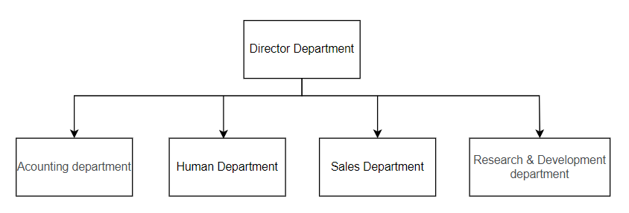

**2.1.3. Survey of business processes, major activities**

***2.1.3.1.Accounting Department***

***Revenue and expenditure management business:*** The accounting division maintains records of the goods and services the company has purchased and makes sure that all business expenses are paid on schedule.

* Revenue and expenditure management process:

1. Keep track of all scheduled payments within the organization.
2. Receive invoices from suppliers, record them, and then process the payments.
3. Identify areas that can cut costs and save money
4. Track and record cash payments
5. Create and track invoices

***Counting salary business:*** Payroll management is a vital profession. They maintain employee morale by paying their on period and on plan. The department must ensure that employee profits are up to date and estimate any remaining wages or bonuses after appropriate deductions have been made.

* Counting salary process:

1. Compute bonuses, benefits, and commissions for employees
2. Hold a record of employee vacation, sick leave, and absences.
3. On behalf of the company, charge government taxes on time.

Financial reporting business: Prepare accurate financial statements and reports for the company. The company relies on these financial statements to make better decisions, forecast, and prepare budgets.

* Process of financial reporting business:

1. Arrange accounting documents.
2. Accounting for economic transactions that occur.
3. Classification of arising transactions by month/quarter.
4. Examining and summarizing transactions from each account group.
5. Perform general accounting and revenue transfer.
6. Financial records.

***2.1.3.2. Human Department***

***Human resource management business:*** monitor the activities of all employees in the company, including employee information management process, employee activity management process and other processes.

* Employee information management process:

1. Recruitment.
2. Enter employee information.
3. Update employee information.

* Employee activity management process:

1. Employee working hours and activity history.
2. Periodic reports on employee activities.

***2.1.3.3. Sales Department***

***Financial consulting business:*** Conduct financial advisory activities, including cash flow, financial structure, cost control, information technology, and governance, as well as other financial matters.

* The financial consulting process

1. Analyze the capital and profit information of the account to clearly determine long-term goals for the business.
2. Consider the items of the business and decide which items should be kept for further development, which should be changed or canceled.
3. Consulting on difficult issues in business activities, implementing projects and financial plans according to business needs.

***Product development profession business:*** Researching and analyzing information about market demand to advise the Board of Directors on product development orientation in order to meet the needs of the market.

* Product development planning process

1. Market demand research
2. Evaluate the business performance of products. From there, find ways to improve the quality of products.
3. Conduct research and develop new products.

***2.1.3.4. Research & Development Department***

***Product research & development business:*** Investigate the properties, benefits, and drawbacks of products, etc., in order to make changes to meet the actual needs of customers.

* Process of Product research & development business:

1. Brainstorm & refine ideas
2. Develop and test ideas
3. Marketing Strategy Development
4. Financial plan analysis
5. Product development

***Research and development in technology business:*** Using technology in product development and optimization to create new products with higher quality while remaining cost-effective.

***Process Research & Development business:*** Investigate scientific and reasonable processes for applying to products, and collaborate with other departments to conduct research and data analysis to broaden the scope of making full use of resources.

**2.2. Software requirements**

**2.2.1. Functional requirements**

***2.2.1.1. Storage function***

The storage feature is one of the most important features of the system, which is the basis for implementing the system's features. To ensure effective management, the system needs to store the following information:

* Employee information: name, date of birth, communications, department information, citizenID
* Department information: department name
* User information: username, password, role, email
* Salary information: employee ID, base salary, date, allowance
* Positions information: position name

***2.2.1.2. Feature function***

In addition, the system must also meet the following requirements:

* Query function: able to respond to query requests from employees/managers such as: find employees information, find salary information, find day-off information,...
* Statistical, analysis, reporting functions: help management staff monitor the general situation of the company.
* Update function: the system must ensure that the update function is convenient and avoid errors due to the user's negligence.
* Automatic functions: help users more conveniently in operation such as automatic salary calculation,...

**2.2.2. Non-functional requirements**

* Customer GUI requirements: multilingual, friendly interface, highly interactive.
* The management GUI: simple, close as report as possible, easy to query.
* Quality requirements:
* Evolution: Easy to upgrade or increase utility modules.
* Convenience:
* The system has an intuitive, user-friendly and easy-to-use interface.
* Clear specifications and instructions for use.
* Efficiency:
* The application shows human resource management well.
* The application works stably and reliably.
* Compatibility: Multi-adaption with popular operating systems (Windows, OS, Ubuntu,...).

**CHAPTER 3: ANALYSIS AND DESIGN**

**3.1. Use-case Diagram**

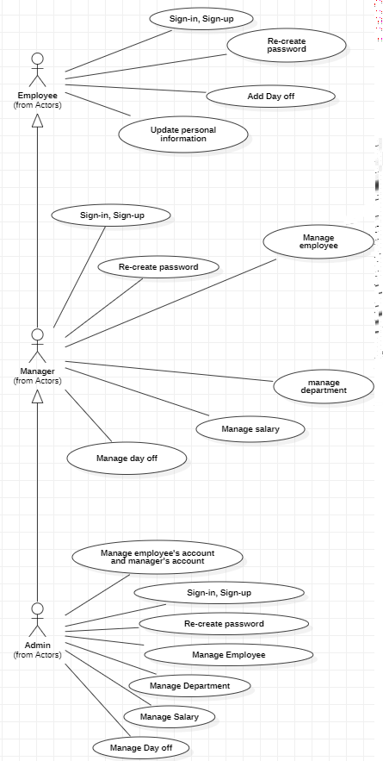

Diagram 1: Use case diagram as process management

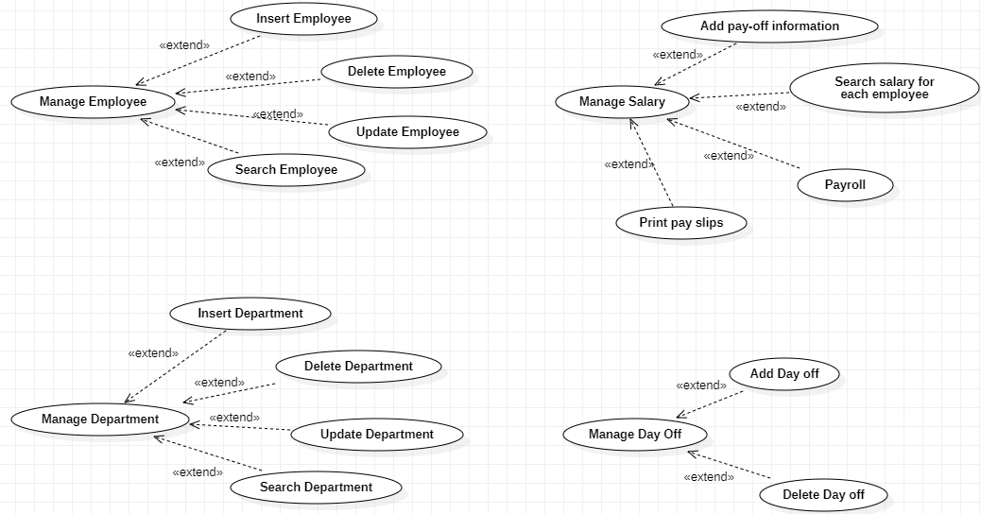

*Diagram 2: Administrator use-case diagram in management*

**3.1.1. List of actors**

|  |  |  |
| --- | --- | --- |
| **Index** | **Actors** | **Meaning** |
| 1 | Admin | People who is an online learning system administrator. |
| 2 | Manager | People who sign in to use system service in order to manage employees, salary, statistic |
| 3 | Employee | People who sign in to see and update their information |

**3.1.2. List of Use-case**

|  |  |  |  |
| --- | --- | --- | --- |
| **STT** | **Role** | **Usecase** | **Meaning** |
| 1 | Manager’s role | Sign up | Sign up for a manager. |
| 2 |  | Sign in | Sign in for using services. |
|  |  | Re-createpassword | This is a method to change password of user. |
|  |  | Manage Employee | Insert/ Delete/ Update/ Search of employee. |
|  |  | Manage Department | Insert/ Delete information of department. |
|  |  | Manage Salary | Manage salary information of each employee, calculate salary for employees and print pay slips |
|  |  | Manage Day off | Insert/ Delete furlough for employee |
|  | Employee’s role | Sign up | Sign up for an employee. |
|  |  | Sign in | Sign in for using services. |
|  |  | Re-createpassword | This is a method to change password of user. |
|  |  | Add Day off | Employees add days off for management review |
|  |  | Update personal information | Employees can edit personal information by themselves |
|  | Admin’s role | Sign in | Sign in for using services. |
|  |  | Sign up | Sign up for a Admin. |
|  |  | Re-createpassword | This is a method to change password of user. |
|  |  | Manage Employee | Insert/ Delete/ Update/ Search of employee. |
|  |  | Manage Department | Insert/ Delete information of department. |
|  |  | Manage Salary | Manage salary information of each employee, calculate salary for employees and print pay slips |
|  |  | Manage Day off | Insert/ Delete furlough for employee |

**3.2. Use-case specification and activity diagram (Activity Diagram)**

**3.2.1 Sign-in**

|  |  |
| --- | --- |
| **Use-case name** | **Sign in** |
| Description | Employees (Manager/ Admin) use an existing account to sign-in to the system to use services. |
| Trigger | Employee (Manager/ Admin) clicks the “Sign in” button. |
| Pre-condition | - Employee’s (Manager/ Admin) device must be connected to the internet.  - Employee’s (Manager/ Admin) account existed |
| Post-condition | - Employee (Manager/ Admin) gets a notification about signing in successfully.  - Employee (Manager/ Admin) redirected to home page and customers can use services |
| Basic flow | 0. Employee (Manager/ Admin) clicks on the sign in button.  1. System display sign in page.  2. Employees (Manager/ Admin) enter username & password and click confirm.  3. System validates the username & password in the correct format.  4. System validate employee’s (Manager/ Admin) input data with existed account data in database.  5. System store sign-in status using sessions.  6. System displays successful signed-in and redirects to the home page. |
| Alternative flow | 3a. System displays invalid information due to the wrong format. Use-case continues at step 2.  4a. System display invalid information due to manager’s account  information does not match with existing account information in the database.  Use-case continues at step 2. |
| Exception flow |  |

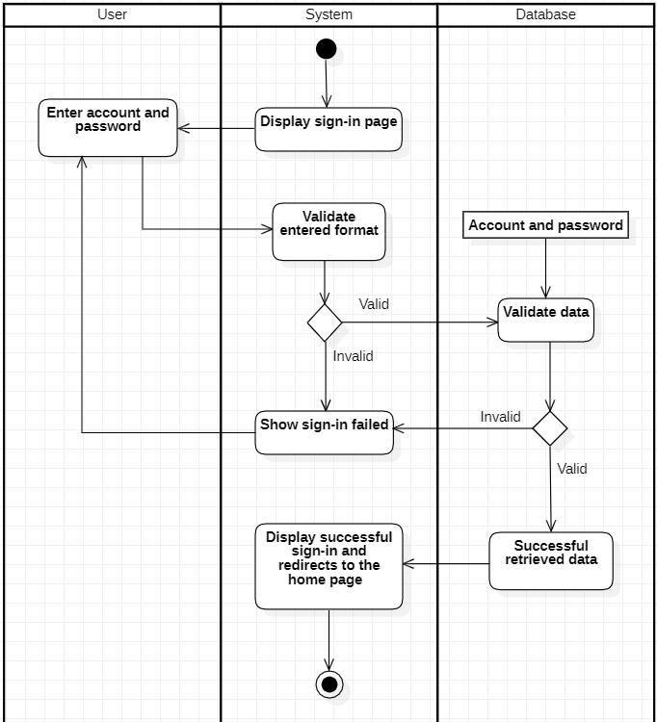

**3.2.2. Re-create password**

|  |  |
| --- | --- |
| **Use-case name** | **Re-create password** |
| Description | User forgot the account password so can’t sign-in. |
| Trigger | User clicks the “Change password” button. |
| Pre-condition | - User device must be connected to the internet.  - User account existed.  - User forgot their password can’t sign-in.  - User must remember to sign-up email. |
| Post-condition | - User password will be updated in the database. |
| Basic flow | 1. System display change password page.  2. Employees enter old and new passwords.  3. System validates the User old password.  4. System validates the old password of the User in the database.  5. System generates new passwords and updates them in the database. |
| Alternative flow | 3a. System displays invalid information due to the wrong format  Use-case continues at step 2. |
| Exception flow |  |

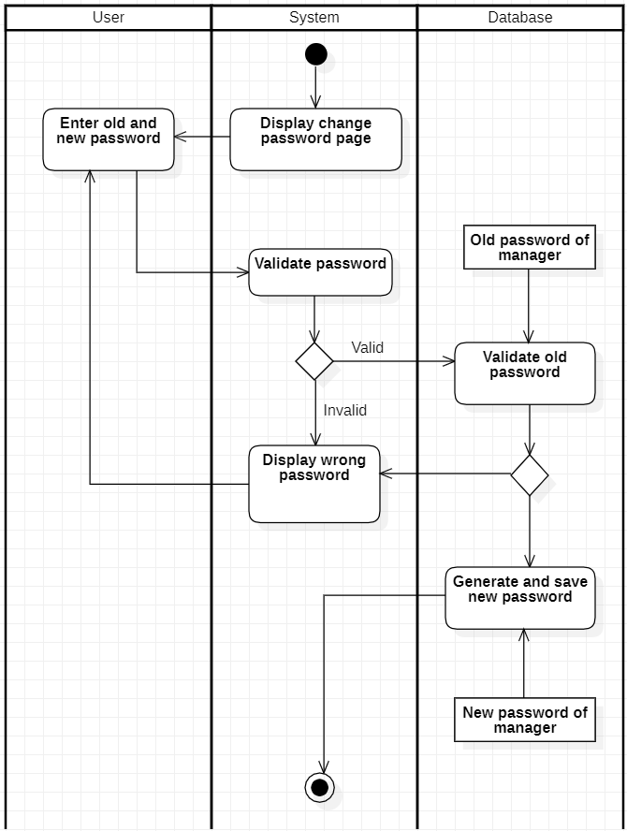

**3.2.3 Update personal information**

|  |  |
| --- | --- |
| **Use-case name** | **Update personal information (for employee)** |
| Description | Employees have changed information that needs to be updated. |
| Trigger | Employee clicks the “Update” button. |
| Pre-condition | - Employee’s device must be connected to the internet.  - Employee’s account existed.  - Employee’s status is sign-in. |
| Post-condition | - Employees get updates with detailed information. |
| Basic flow | 1. System display employee page with data loaded from database.  2. Employees select information to be updated.  3. System displays information from existing data .  4. Employees enter information and submit.  5. System validates information in the correct format.  6. System validates information from existing data in the database.  7. System update information in database.  8. System update information in employee page and display update successful. |
| Alternative flow | 5a. System displays invalid information due to the wrong format. Use-case continues at step 4.  6b. System display invalid information because data hadn’t been existed in  database  Use-case continues at step 4. |
| Exception flow |  |

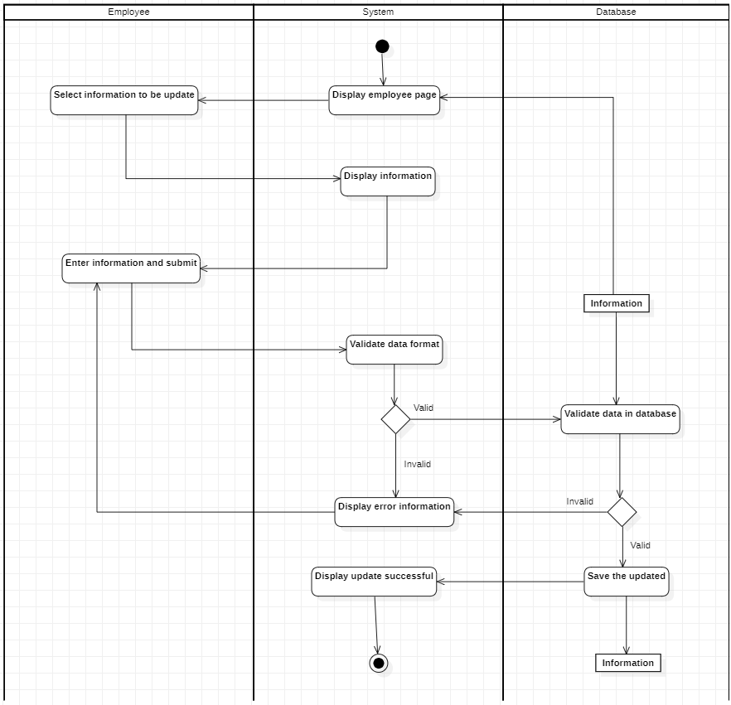

**3.2.4 Add Day off**

|  |  |
| --- | --- |
| **Use-case name** | **Add Day off (for employee)** |
| Description | Employees can add a new day off in their list of days off. |
| Trigger | Employees click the “Add new” button in the Day off bar. |
| Pre-condition | - Employee’s device must be connected to the internet.  - Employee’s account existed.  - Employee’s status is sign-in. |
| Post-condition | Employees see the listing page. |
| Basic flow | 1. System display Day off page with data loaded from database.  2. Employee select add function.  3. System display add information page.  4. Employee enters information.  5. System validates information in the correct format.  6. System validates information with existing data in the database.  7. System stores information in a database.  8. System displays information on the Day off page of the Employee. |
| Alternative flow | 5a. System displays invalid information due to the wrong format. Use-case continues at step 4.  6b. System display invalid information because data hadn’t been existed in  database  Use-case continues at step 4. |
| Exception flow |  |

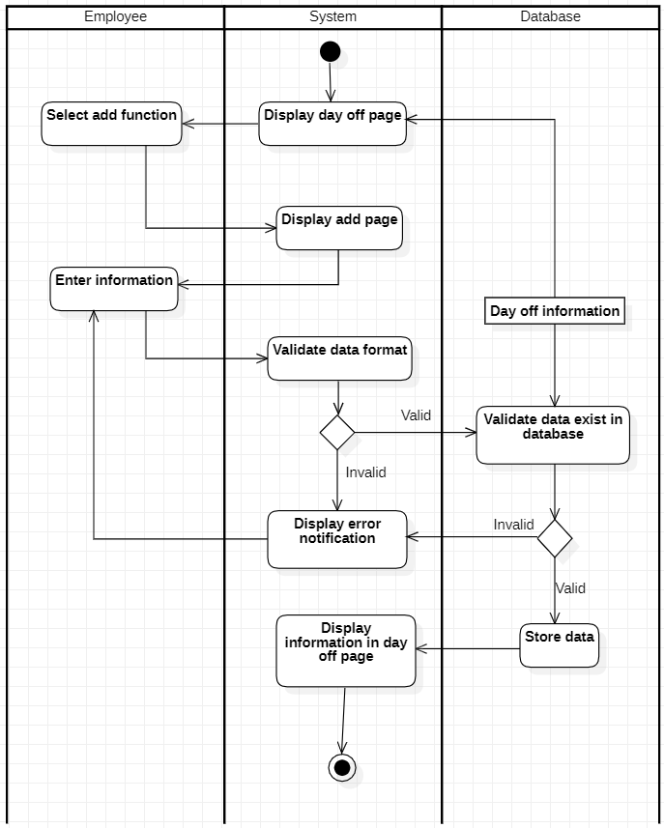

**3.2.5 Sign-up**

|  |  |
| --- | --- |
| **Use-case name** | **Sign up** |
| Description | User creates an account to use system service. |
| Trigger | User clicks on the button “Sign up”. |
| Pre-condition | User device must be connected to the internet. |
| Post-condition | - User gets a notification about signing up successfully.  - User’s account was created and can be used to sign in for a next time. |
| Basic flow | 0. User clicks on the “Sign up” button.  1. System display sign up page.  2. User enter information such as email, password, name, ... and  click confirm button.  3. System validates the user entered information in the correct format.  4. System validates the user's information uniquely in the database.  5. System stores the user’s account information in the database.  6. System notify user that account was created, user can sign-in by using this account. |
| Alternative flow | 3a. System displays invalid information due to the wrong format. Use-case continues at step 2.  4a. System display invalid information due to maybe have an existed  account with user entered information.  Use-case continues at step 2. |
| Exception flow |  |

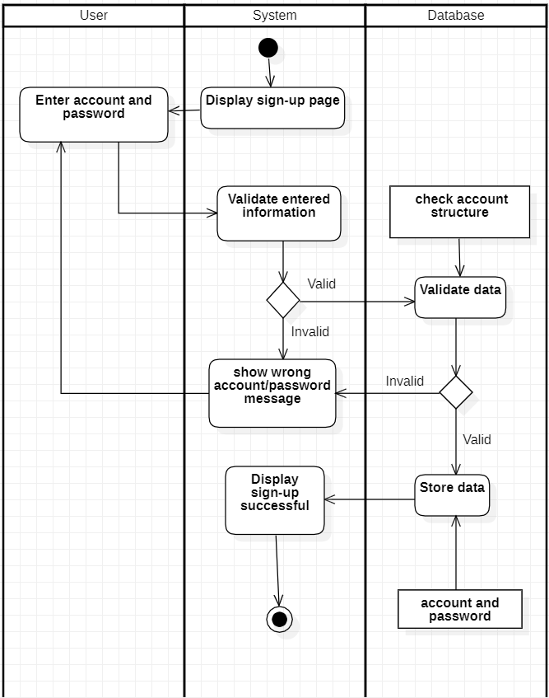

**3.2.6 Manage Employee**

*3.2.6.1. Insert employee*

|  |  |
| --- | --- |
| **Use-case name** | **Insert employee (for manager)** |
| Description | Manager can insert employee information to the database. |
| Trigger | Manager clicks the “ Add new” button in the management page. |
| Pre-condition | - Manager’s device must be connected to the internet.  - Manager’s account existed.  - Manager’s status to signed-in |
| Post-condition | - Employee information successfully inserted into the database. |
| Basic flow | 1. System display management page with data loaded from database.  2. Manager select insert function.  3. System display employee information page.  4. Manager enters employee information.  5. System validates employee information in the correct format.  6. System validates employee information with existing data in the database.  7. System stores employee information in a database.  8. System displays successful notifications. |
| Alternative flow | 5a. System displays invalid information due to the wrong format. Use-case continues at step 4.  6b. System displays invalid information because data has existed in the database. Use-case continues at step 4. |
| Exception flow |  |

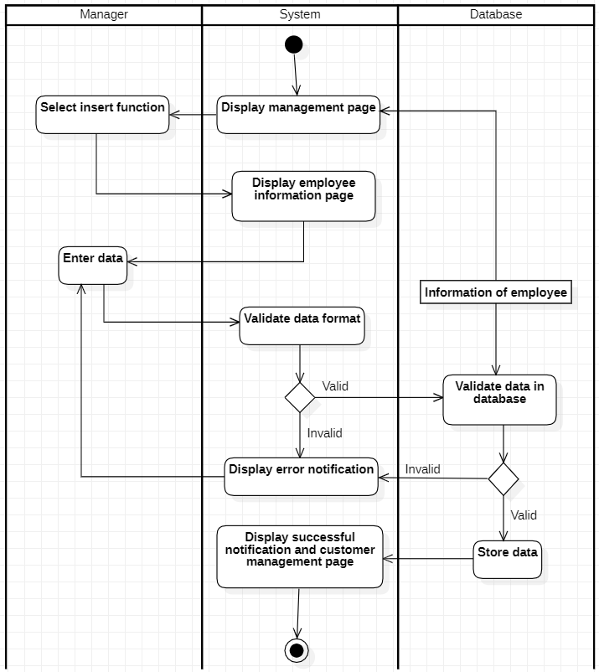

*3.2.6.2. Update Employee*

|  |  |
| --- | --- |
| **Use-case name** | **Update Employee (for manager)** |
| Description | Manager can update an existing employee information in the database. |
| Trigger | Manager clicks the “ Update ” button on the manager page. |
| Pre-condition | - Manager’s device must be connected to the internet.  - Manager’s account existed.  - Manager’s status to signed-in.  - Employee information must exist in the database. |
| Post-condition | - Data in the management page is updated. |
| Basic flow | 1. System display management page with data loaded from database.  2. Manager selects information to be updated.  3. System displays employee information from existing data .  4. Manager enters employee information and submits.  5. System validates employee information in the correct format.  6. System validates employee information from existing data in the database.  7. System update employee information in database.  8. System update employee information in management page and display update successful. |
| Alternative flow | 5a. System displays invalid information due to the wrong format. Use-case continues at step 4.  6b. System displayed invalid information because data hadn't existed in the database. Use-case continues at step 4. |
| Exception flow |  |

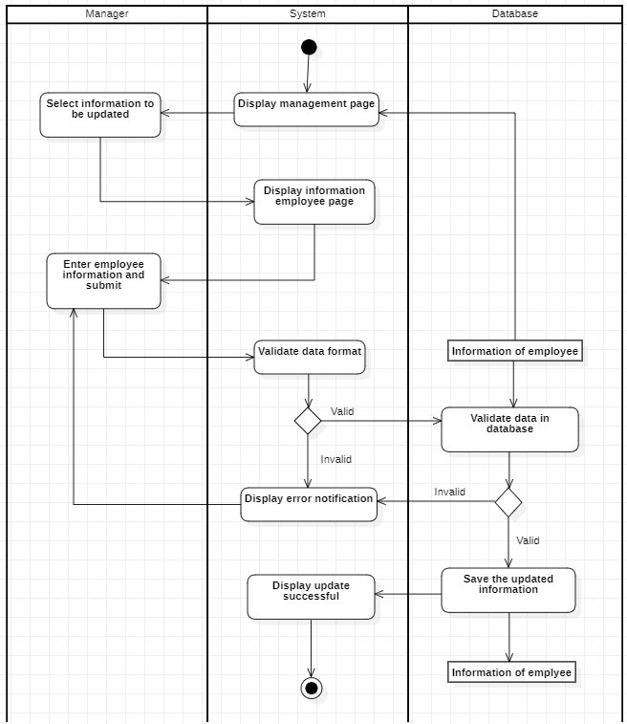

*3.2.6.3 Delete Employee*

|  |  |
| --- | --- |
| **Use-case name** | **Delete Employee (for manager)** |
| Description | Manager can delete existing employee information in the database. |
| Trigger | Manager clicks the “ Delete ” button on the manager page. |
| Pre-condition | - Manager’s device must be connected to the internet.  - Manager’s account existed.  - Manager’s status to signed-in.  - Employee information must exist in the database.  - No external data involved . |
| Post-condition | - Data in the management page is updated (selected information has been deleted). |
| Basic flow | 1. System display management page with data loaded from database.  2. Select delete function and information to be deleted.  3. System display confirms delete.  4. Manager confirmed the decision.  5. System process delete request.  6. System check availability of delete requests.  7. System delete employee information in database.  8. System display successful. |
| Alternative flow |  |
| Exception flow | 6a. System display error notification because external data had required that information or no data existed.  Use-case stop |

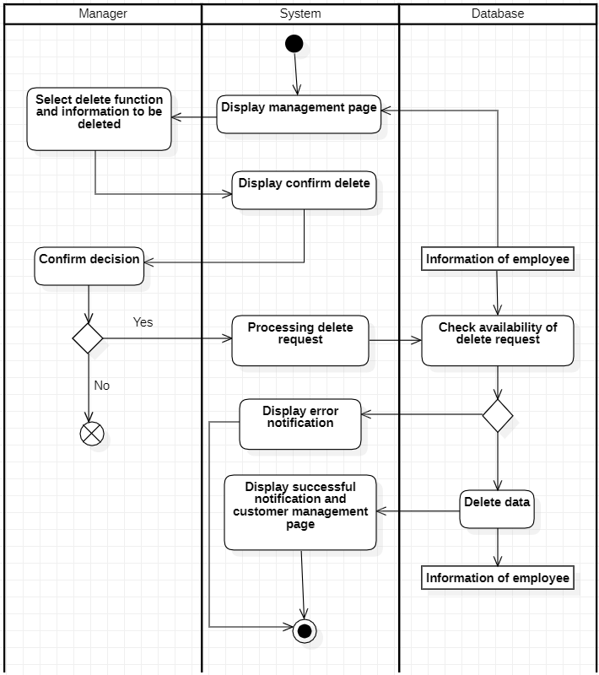

*3.2.6.4. Search Employee*

|  |  |
| --- | --- |
| **Use-case name** | **Search Employee (for manager)** |
| Description | Manager can search for existing employee information in the database. |
| Trigger | Manager clicks the “ Search ” bar on the manager page. |
| Pre-condition | - Manager’s device must be connected to the internet.  - Manager’s account existed.  - Manager’s status to signed-in. |
| Post-condition | - Data at the management page is filtered by keyword. |
| Basic flow | 1. System display management page with data loaded from database (existed data).  2. Manager enters the keyword in the search box.  3. System processes search data.  4. System queries database on keyword.  5. System update data at management page. |
| Alternative flow | 4a. System display not found notification .  Use-case continues at step 5 (no data is retained). |
| Exception flow |  |

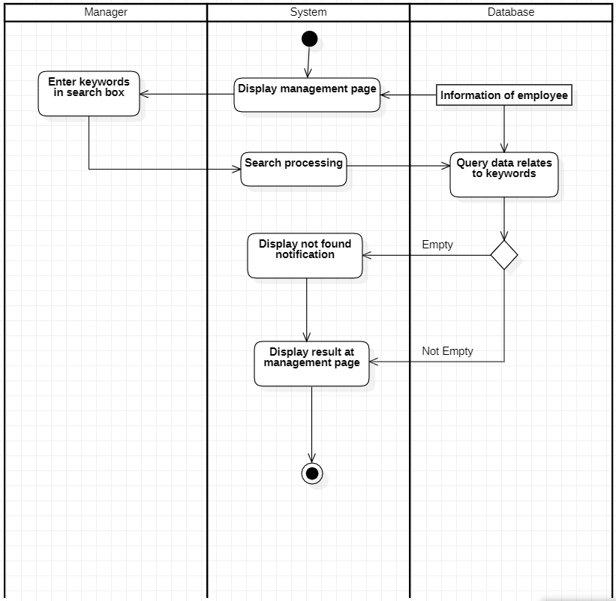

**3.2.7 Manage Department**

*3.2.7.1 Insert Department*

|  |  |
| --- | --- |
| **Use-case name** | **Insert Department (for manager)** |
| Description | Manager can insert department information to the database. |
| Trigger | Manager clicks the “ Add new” button in the management page. |
| Pre-condition | - Manager’s device must be connected to the internet.  - Manager’s account existed.  - Manager’s status to signed-in. |
| Post-condition | - Department information successfully inserted into the database. |
| Basic flow | 1. System display management page with data loaded from database.  2. Manager select insert function.  3. System display department information form.  4. Manager enters department information.  5. System validates department information in the correct format.  6. System validates department information with existing data in the database.  7. System store department information in database.  8. System update data at the department admin page . |
| Alternative flow | 5a. System displays invalid information due to the wrong format. Use-case continues at step 4.  6b. System displays invalid information because data has existed in the database. Use-case continues at step 4. |
| Exception flow |  |

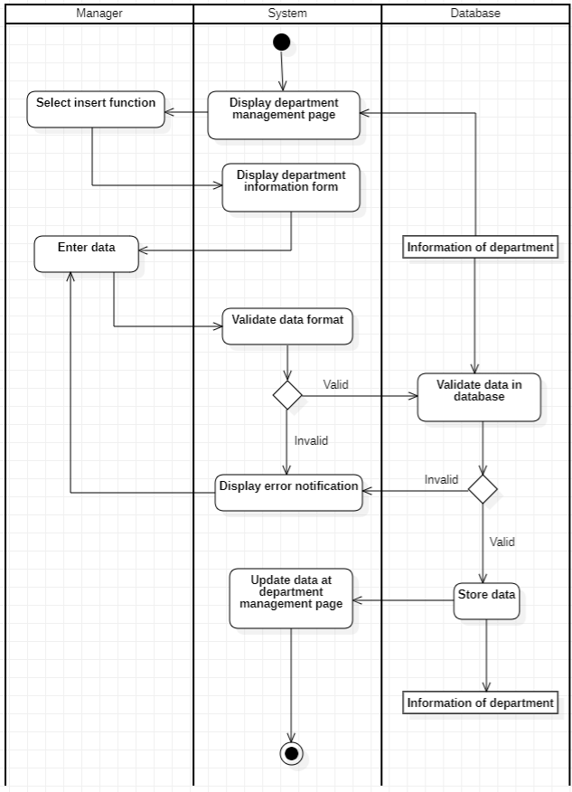

*3.2.7.2 Delete Department*

|  |  |
| --- | --- |
| **Use-case name** | **Delete Department (for manager)** |
| Description | Manager can delete an existing department in the database. |
| Trigger | Manager clicks the “ Delete ” button on the Department page of the manager. |
| Pre-condition | - Manager’s device must be connected to the internet.  - Manager’s account existed.  - Manager’s status to signed-in.  - Department information must exist in the database.  - No external data involved . |
| Post-condition | - Data in the management page is updated (selected information has been deleted). |
| Basic flow | 1. System display Department page with data loaded from database.  2. Select delete function and information to be deleted.  3. System processes delete requests.  4. System validates no external data required department information and selected information exists in the database.  5. System delete department information in database.  6. System update data at department page. |
| Alternative flow |  |
| Exception flow | 5a. System display error notification because external data had required that information or no data existed.  Use-case stop |

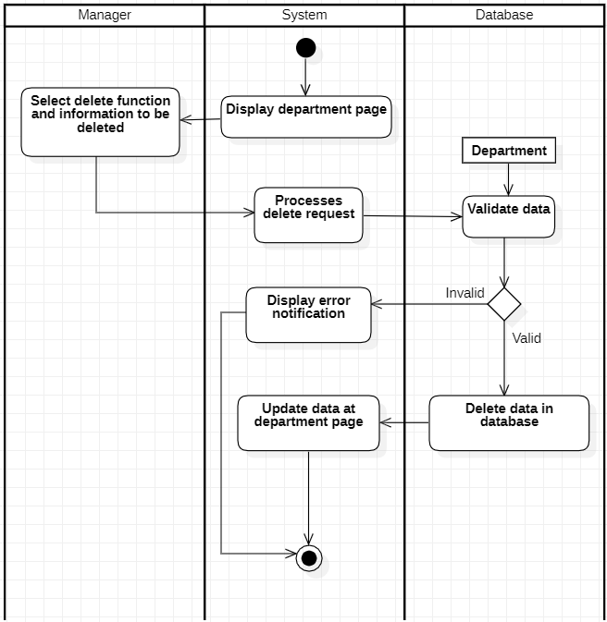

**3.2.8 Manage Salary**

*3.2.8.1 Add pay off information*

| **Use-case name** | **Add pay off information (for Manager)** |
| --- | --- |
| Description | Manager can add pay off information to the database. |
| Trigger | Manager clicks the “Add” button in the pay off management page . |
| Pre-condition | - Manager’s device must be connected to the internet.  - Manager’s account existed.  - Manager’s status to signed-in |
| Post-condition | - Pay off information successfully inserted into the database. |
| Basic flow | 1. System display management page with data loaded from database.  2. Manager select pay off detail function.  3. System display pay off information page.  4. Manager enters information and clicks the add button.  5. System validates information in the correct format.  6. System stores information in a database.  7. System displays updated to the list on the pay off information page. |
| Alternative flow | 5a. System displays invalid information due to the wrong format. Use-case continues at step 4. |
| Exception flow |  |

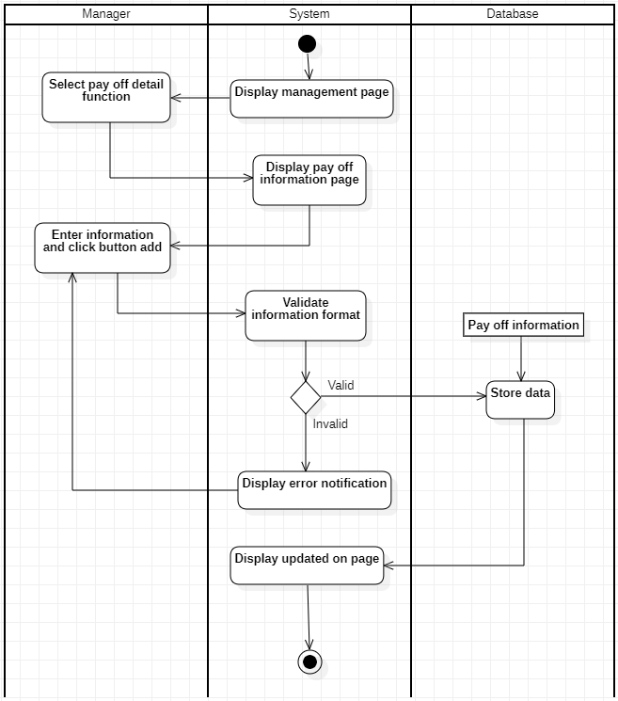

*3.2.8.2 Payroll*

|  |  |
| --- | --- |
| **Use-case name** | **Payroll (for Manager)** |
| Description | Manager can calculate the salary of each employee. |
| Trigger | Bonus/penalty on one time plus/minus 100,000VND. |
| Pre-condition | - Manager’s account existed.  - Manager’s status to signed-in.  - Manager’s using devices with software available. |
| Post-condition | - The new salary and penalty bonus has been updated on  Database. |
| Basic flow | 1. System display salary and bonus information page.  2. Manager select update reason function.  3. Manager entered the reason.  4. System validate information format.  5. System stores information in the database.  6. System display result at salary and bonus information page. |
| Alternative flow | 4a. System display error notification.  Use-case continues at step 3. |
| Exception flow |  |

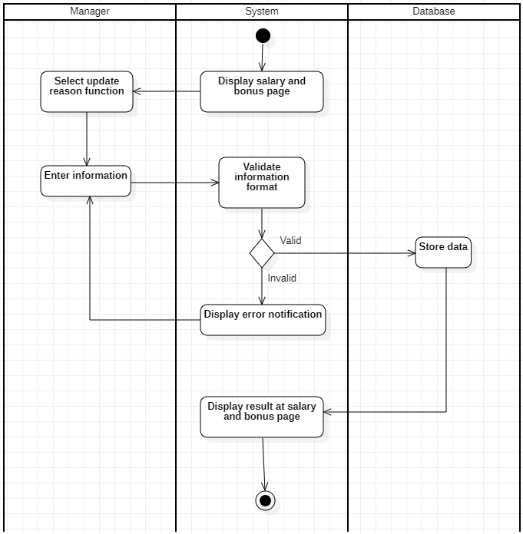

*3.2.8.3 Print pay slips*

|  |  |
| --- | --- |
| **Use-case name** | **Print pay slips (for Manager)** |
| Description | Manager can print out payslips. |
| Trigger | Manager clicks the “PrintSalary” button. |
| Pre-condition | - Manager’s account existed.  - Manager’s status to signed-in.  - Manager’s using devices with software available. |
| Post-condition | None. |
| Basic flow | 1. System displays a personal employee information page.  2. Manager select print function.  3. System validates the employee’s salary format.  4. System validates the existence of an employee's salary in the database.  5. System display print result. |
| Alternative flow |  |
| Exception flow | 4.a System does not display anything.  Use-case stop |

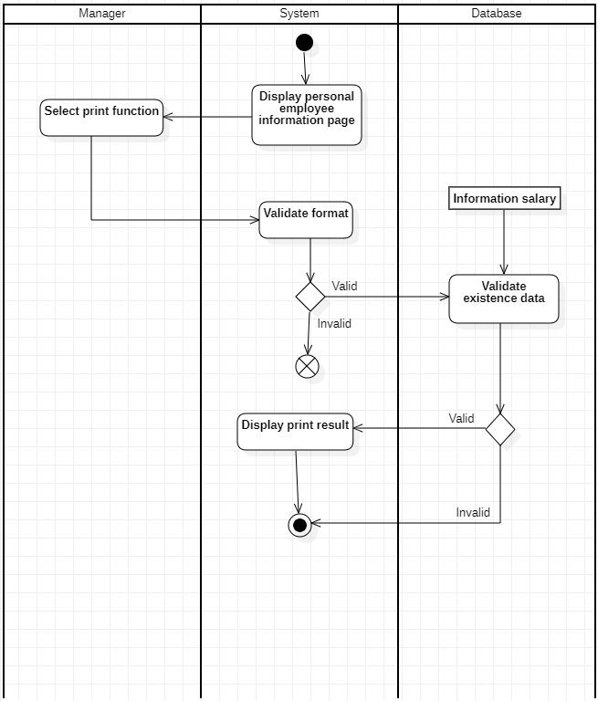

*3.2.8.4 Search Salary of each employee*

|  |  |
| --- | --- |
| **Use-case name** | **Search Salary (for Manager)** |
| Description | Manager can search for existing information in the database. |
| Trigger | Manager clicks the “Search” bar on the salary information page. |
| Pre-condition | - Manager’s device must be connected to the internet.  - Manager’s account existed.  - Manager’s status to signed-in. |
| Post-condition | - Data at the salary information page is filtered by keyword. |
| Basic flow | 1. System display salary information page with data loaded from database (existing data).  2. Manager enters the keyword in the search box.  3. System processes search data.  4. System queries database on keyword.  5. System result at salary information page. |
| Alternative flow |  |
| Exception flow | 4a. System does not display anything on the list of employee information pages .  Use-case stop. |

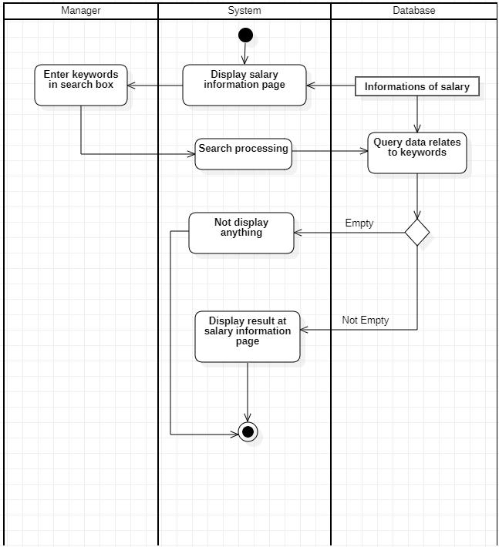

**3.2.9 Manage Day Off**

*3.2.9.1 Delete Day off*

|  |  |
| --- | --- |
| **Use-case name** | **Delete Day off (for manager)** |
| Description | Manager can delete existing furlough information in the database. |
| Trigger | Manager clicks the “Delete” button on the furlough information page. |
| Pre-condition | - Manager’s device must be connected to the internet.  - Manager’s account existed.  - Manager’s status to signed-in.  - Furlough information must exist in the database.  - No external data involved . |
| Post-condition | - Data in the furlough page is updated (selected information has been deleted). |
| Basic flow | 1. System display furlough page with data loaded from database.  2. Select delete function and information to be deleted.  3. System process delete request.  4. System check availability of delete requests.  5. System delete furlough information in database.  6. System update data at furlough information page. |
| Alternative flow |  |
| Exception flow | 6a. System display error notification because external data had required that information or no data existed.  Use-case stop |

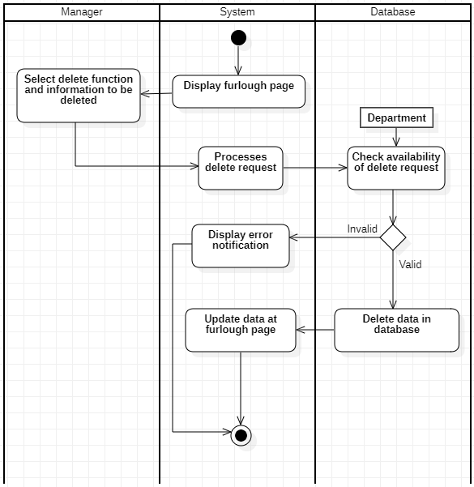

*3.2.9.2 Add Day off*

|  |  |
| --- | --- |
| **Use-case name** | **Add Day off (for Manager)** |
| Description | Managers can add a new day off in their list of days off. |
| Trigger | Manager clicks the “Add new” button in the Day off bar. |
| Pre-condition | - Manager’s device must be connected to the internet.  - Manager’s account existed.  - Manager’s status is sign-in. |
| Post-condition | Manager sees the listing page. |
| Basic flow | 1. System display furlough page with data loaded from database.  2. Manager select add function.  3. System display add information page.  4. Manager enters information.  5. System validates information in the correct format.  6. System validates information with existing data in the database.  7. System stores information in a database.  8. System displays information on the furlough page. |
| Alternative flow | 5a. System displays invalid information due to the wrong format. Use-case continues at step 4.  6b. System display invalid information because data hadn’t been existed in  database  Use-case continues at step 4. |
| Exception flow |  |

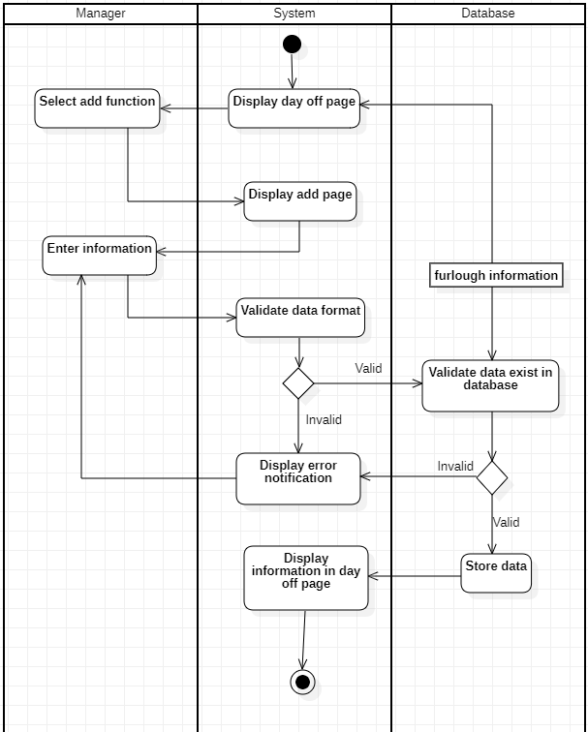

**3.2.10 Manage Employee**

*3.2.10.1 Insert Employee*

| **Use-case name** | **Insert employee (for Administrator)** |
| --- | --- |
| Description | Administrators can insert employee information to the database. |
| Trigger | Administrator clicks the “ Add new” button in the admin page. |
| Pre-condition | - Administrator’s device must be connected to the internet.  - Administrator’s account existed.  - Administrator’s status to signed-in |
| Post-condition | Employee information successfully inserted into the database. |
| Basic flow | 1. System display admin page with data loaded from database.  2. Administrator select insert function.  3. System display employee information page.  4. Administrator enters employee information.  5. System validates employee information in the correct format.  6. System validates employee information with existing data in the database.  7. System stores employee information in a database.  8. System displays updates to the list on the employee information page. |
| Alternative flow | 5a. System displays invalid information due to the wrong format. Use-case continues at step 4.  6b. System displays invalid information because data has existed in the database. Use-case continues at step 4. |

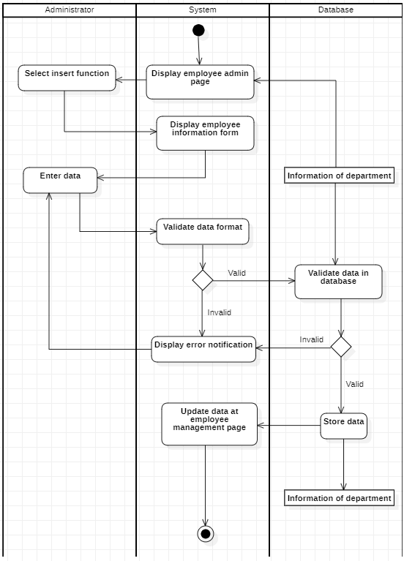

*3.2.10.2 Delete Employee*

|  |  |
| --- | --- |
| **Use-case name** | **Delete Employee (for Administrator)** |
| Description | Administrators can delete existing employee information in the database. |
| Trigger | Administrator clicks the “ Delete ” button on the manager page. |
| Pre-condition | - Administrator’s device must be connected to the internet.  - Administrator’s account existed.  - Administrator’s status to signed-in.  - Employee information must exist in the database.  - No external data involved . |
| Post-condition | Data in the admin page is updated (selected information has been deleted). |
| Basic flow | 1. System display admin page with data loaded from database.  2. Select delete function and information to be deleted.  3. System display confirms delete.  4. Manager confirmed the decision.  5. System process delete request.  6. System check availability of delete requests.  7. System delete employee information in database.  8. System update data at employee information page. |
| Alternative flow |  |
| Exception flow | 6a. System display error notification because external data had required that information or no data existed.  Use-case stop |

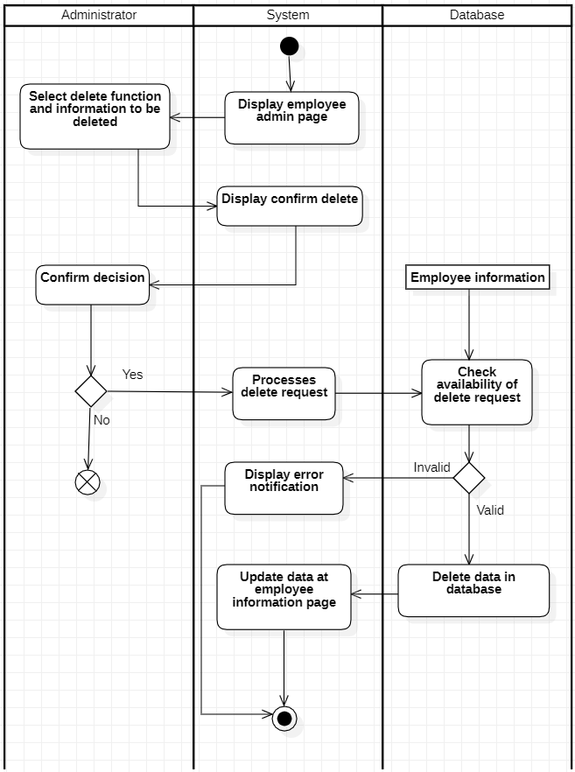

*3.2.10.3 Update Employee*

|  |  |
| --- | --- |
| **Use-case name** | **Update Employee (for Administrator)** |
| Description | Administrators can update an existing employee information in the database. |
| Trigger | Administrators click the “Update” button on the manager page. |
| Pre-condition | - Administrator’s device must be connected to the internet.  - Administrator’s account existed.  - Administrator’s status to signed-in.  - Employee information must exist in the database. |
| Post-condition | Data in the admin page is updated. |
| Basic flow | 1. System display Administrators page with data loaded from database.  2. Admin selects information to be updated.  3. System displays employee information from existing data .  4. Admin enters employee information.  5. System validates employee information in the correct format.  6. System validates employee information from existing data in the database.  7. System update employee information in database.  8. System update employee information in the Administrators page. |
| Alternative flow | 5a. System displays invalid information due to the wrong format. Use-case continues at step 4.  6b. System displayed invalid information because data hadn't existed in the database. Use-case continues at step 4. |
| Exception flow |  |

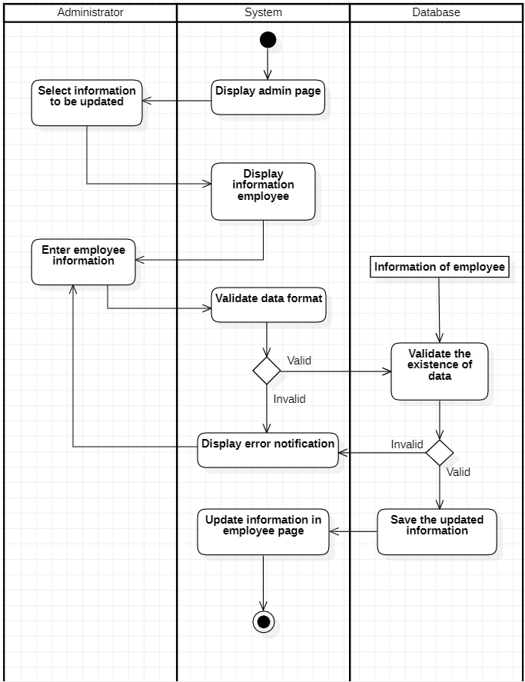

*3.2.10.4 Search Employee*

|  |  |
| --- | --- |
| **Use-case name** | **Search Employee (for Administrator)** |
| Description | Administrators can search for existing employee information in the database. |
| Trigger | Administrator clicks the “Search” bar on the employee information page. |
| Pre-condition | - Administrator’s device must be connected to the internet.  - Administrator’s account existed.  - Administrator’s status to signed-in. |
| Post-condition | - Data at the management page is filtered by keyword. |
| Basic flow | 1. System display employee information page with data loaded from database (existing data).  2. Admin enters the keyword in the search box.  3. System processes search data.  4. System queries database on keyword.  5. System result at employee information page. |
| Alternative flow |  |
| Exception flow | 4a. System does not display anything on the list of employee information pages .  Use-case stop. |

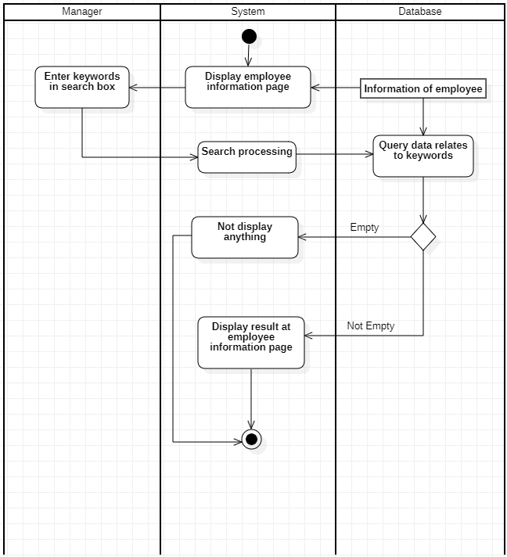

**3.2.11 Manage Department**

*3.2.11.1 Insert Department*

|  |  |
| --- | --- |
| **Use-case name** | **Insert Department (for Administrator)** |
| Description | Administrators can insert department information to the database. |
| Trigger | Administrator clicks the “ Add new” button in the management page. |
| Pre-condition | - Administrator’s device must be connected to the internet.  - Administrator’s account existed.  - Administrator’s status to signed-in. |
| Post-condition | - Department information successfully inserted into the database. |
| Basic flow | 1. System displays the department admin page with data loaded from the database.  2. Admin select insert function.  3. System display department information form.  4. Admin enters department information.  5. System validates department information in the correct format.  6. System validates department information with existing data in the database.  7. System store department information in database.  8. System update data at the department admin page . |
| Alternative flow | 5a. System displays invalid information due to the wrong format. Use-case continues at step 4.  6b. System displays invalid information because data has existed in the database. Use-case continues at step 4. |
| Exception flow |  |

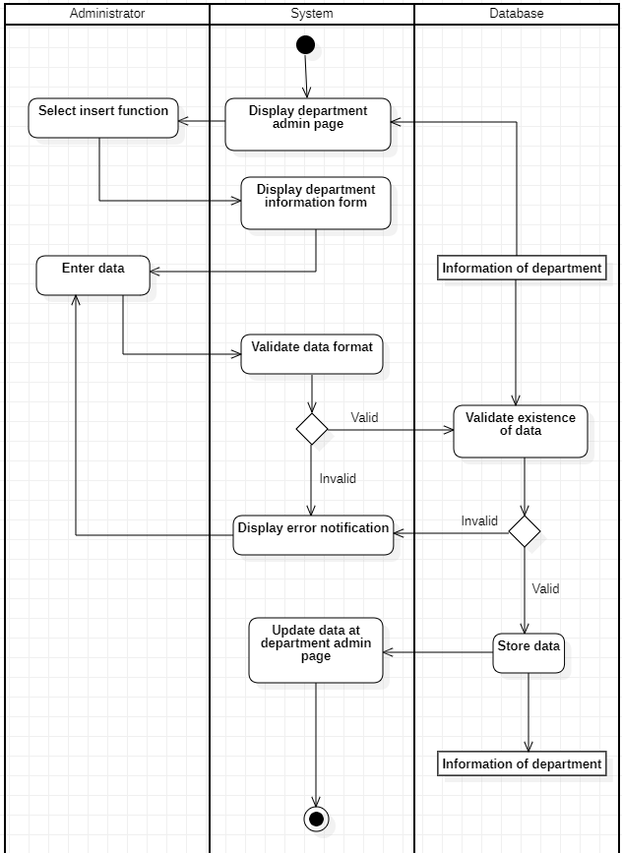

*3.2.11.2 Delete Department*

|  |  |
| --- | --- |
| **Use-case name** | **Delete Department (for Administrator)** |
| Description | Administrators can delete an existing department in the database. |
| Trigger | Administrator clicks the “Delete” button on the department page of the Administrator . |
| Pre-condition | - Administrator’s device must be connected to the internet.  - Administrator’s account existed.  - Administrator’s status to signed-in.  - Department information must exist in the database.  - No external data involved . |
| Post-condition | - Data in the department admin page is updated (selected information has been deleted). |
| Basic flow | 1. System display department page with data loaded from database.  2. Select delete function and information to be deleted.  3. System processes delete requests.  4. System validates no external data required department information and selected information exists in the database.  5. System delete department information in database.  6. System update data at department page. |
| Alternative flow |  |
| Exception flow | 5a. System display error notification because external data had required that information or no data existed.  Use-case stop |

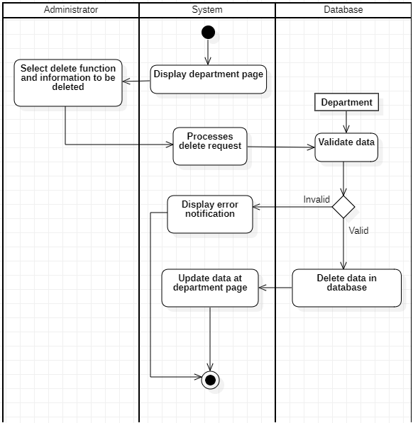

**3.2.12 Manage Salary**

*3.2.12.1 Add pay off information*

| **Use-case name** | **Add pay off information (for Administrator)** |
| --- | --- |
| Description | Administrators can add pay off information to the database. |
| Trigger | Administrator clicks the “Add” button in the pay off management page . |
| Pre-condition | - Administrator’s device must be connected to the internet.  - Administrator’s account existed.  - Administrator’s status to signed-in |
| Post-condition | - Pay off information successfully inserted into the database. |
| Basic flow | 1. System display admin page with data loaded from database.  2. Admin select pay off detail function.  3. System display pay off information page.  4. Admin enters information and clicks the add button.  5. System validates information in the correct format.  6. System stores information in a database.  7. System displays updated to the list on the pay off information page. |
| Alternative flow | 5a. System displays invalid information due to the wrong format. Use-case continues at step 4. |
| Exception flow |  |

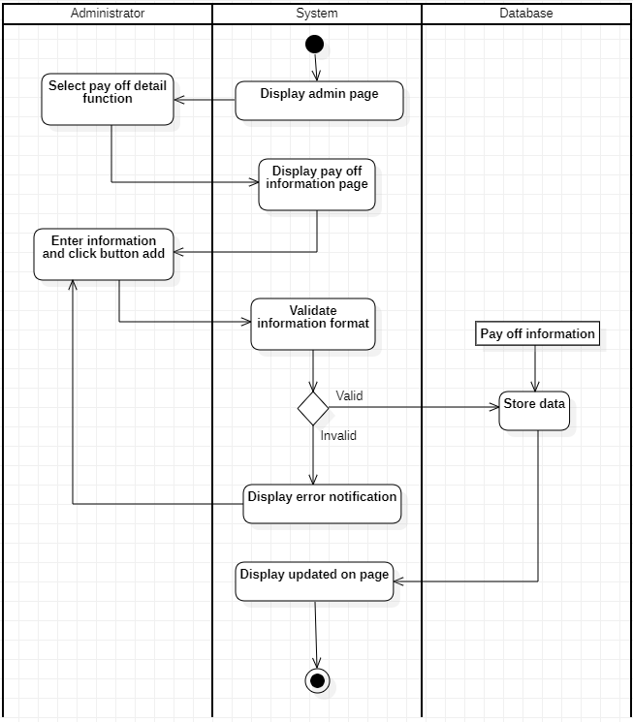

*3.2.12.2 Payroll*

|  |  |
| --- | --- |
| **Use-case name** | **Payroll (for Administrator)** |
| Description | Administrators can calculate the salary of each employee. |
| Trigger | Bonus/penalty on one time plus/minus 100,000VND. |
| Pre-condition | - Administrator’s account existed.  - Administrator’s status to signed-in.  - Administrator’s using devices with software available. |
| Post-condition | - The new salary and penalty bonus has been updated on  Database. |
| Basic flow | 1. System display salary and bonus information page.  2. Admin select update reason function.  3. Admin enter reason.  4. System validate information format.  5. System stores information in the database.  6. System display result at salary and bonus information page. |
| Alternative flow | 4a. System display error notification.  Use-case continues at step 3. |
| Exception flow |  |

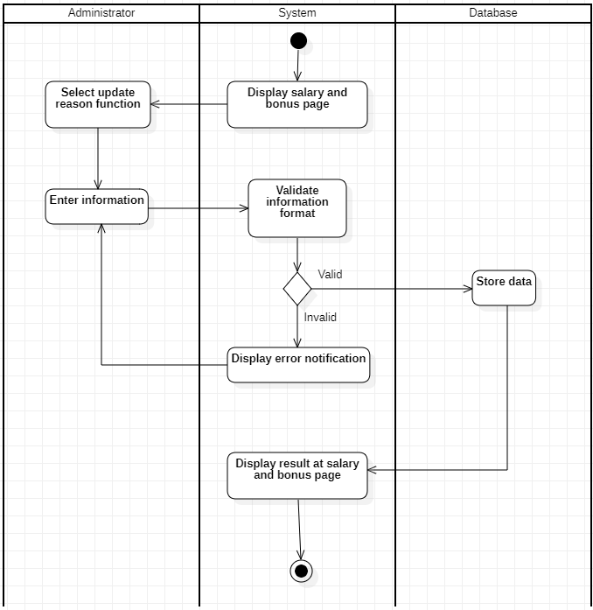

*3.2.12.3 Print pay slips*

|  |  |
| --- | --- |
| **Use-case name** | **Print pay slips (for Administrator)** |
| Description | Administrator can print out pay slips. |
| Trigger | Administrator clicks the “PrintSalary” button. |
| Pre-condition | - Administrator’s account existed.  - Administrator’s status to signed-in.  - Administrator’s using devices with software available. |
| Post-condition | None. |
| Basic flow | 1. System displays a personal employee information page.  2. Manager select print function.  3. System validates the employee’s salary format.  4. System validates the existence of an employee's salary in the database.  5. System display print result. |
| Alternative flow |  |
| Exception flow | 4.a System does not display anything.  Use-case stop |

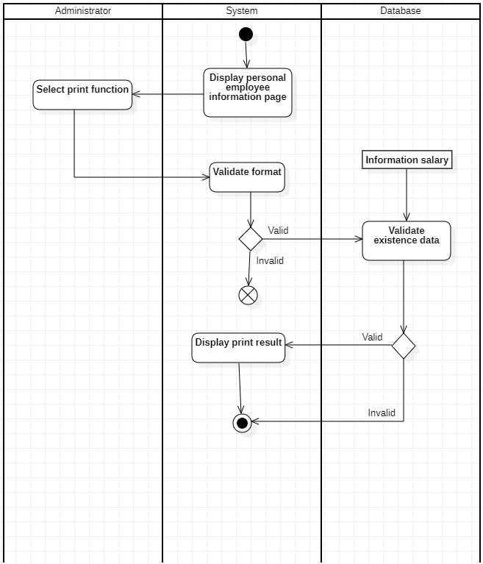

*3.2.12.4 Search salary for each employee*

|  |  |
| --- | --- |
| **Use-case name** | **Search Salary (for Administrator)** |
| Description | Administrators can search for existing information in the database. |
| Trigger | Administrator clicks the “ Search ” bar on the salary information page. |
| Pre-condition | - Administrator’s device must be connected to the internet.  - Administrator’s account existed.  - Administrator’s status to signed-in. |
| Post-condition | - Data at the salary information page is filtered by keyword. |
| Basic flow | 1. System display salary information page with data loaded from database (existing data).  2. Manager enters the keyword in the search box.  3. System processes search data.  4. System queries database on keyword.  5. System result at salary information page. |
| Alternative flow |  |
| Exception flow | 4a. System does not display anything on the list of employee information pages .  Use-case stop. |

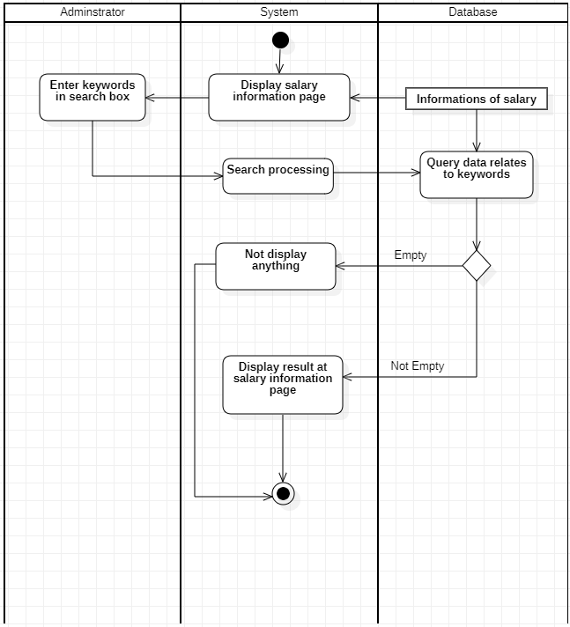

**3.2.13 Manage Day Off**

*3.2.13.1 Delete Day off*

|  |  |
| --- | --- |
| **Use-case name** | **Delete Day off (for Administrator)** |
| Description | Administrators can delete existing furlough information in the database. |
| Trigger | Administrator clicks the “Delete” button on the furlough information page. |
| Pre-condition | - Administrator’s device must be connected to the internet.  - Administrator’s account existed.  - Administrator’s status to signed-in.  - Furlough information must exist in the database.  - No external data involved . |
| Post-condition | - Data in the furlough page is updated (selected information has been deleted). |
| Basic flow | 1. System display furlough page with data loaded from database.  2. Select delete function and information to be deleted.  3. System process delete request.  4. System check availability of delete requests.  5. System delete furlough information in database.  6. System update data at furlough information page. |
| Alternative flow |  |
| Exception flow | 6a. System display error notification because external data had required that information or no data existed.  Use-case stop |

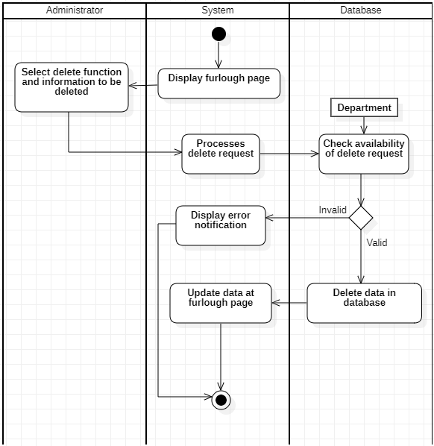

*3.2.13.2 Add Day off*

|  |  |
| --- | --- |
| **Use-case name** | **Add Day off (for Administrator)** |
| Description | Administrators can add a new day off in their list of days off. |
| Trigger | Administrator clicks the “Add new” button in the Day off bar. |
| Pre-condition | - Administrator’s device must be connected to the internet.  - Administrator’s account existed.  - Administrator’s status is sign-in. |
| Post-condition | Administrator sees the listing page. |
| Basic flow | 1. System display furlough page with data loaded from database.  2. Admin select add function.  3. System display add information page.  4. Admin enters information.  5. System validates information in the correct format.  6. System validates information with existing data in the database.  7. System stores information in a database.  8. System displays information on the furlough page. |
| Alternative flow | 5a. System displays invalid information due to the wrong format. Use-case continues at step 4.  6b. System display invalid information because data hadn’t been existed in  database  Use-case continues at step 4. |
| Exception flow |  |

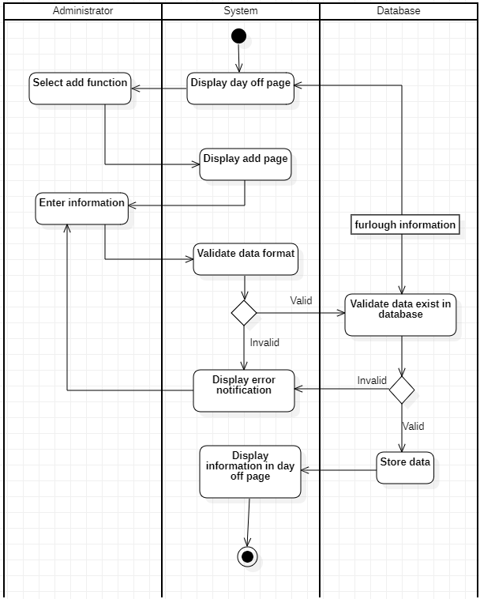

**3.2.14 Manage Manager’s account and Employee account**

|  |  |
| --- | --- |
| **Use-case name** | **Add Day off (for Administrator)** |
| Description | Administrator can manage Manager’s account and Employee’s account. |
| Trigger |  |
| Pre-condition | - Administrator’s account existed.  - Administrator’s status is sign-in.  - Administrator’s using devices with software available. |
| Post-condition |  |
| Basic flow | 1. System display user management page.  2. Admin select user.  3. System displays detailed information about that user. |
| Alternative flow |  |
| Exception flow |  |

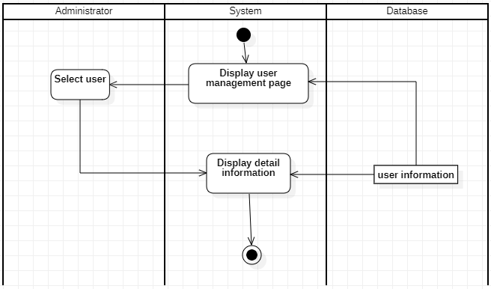

**3.3. Sequence Diagram and Class Diagram**

**3.3.1. Sign up**

*3.3.1.1. Sequence diagram*

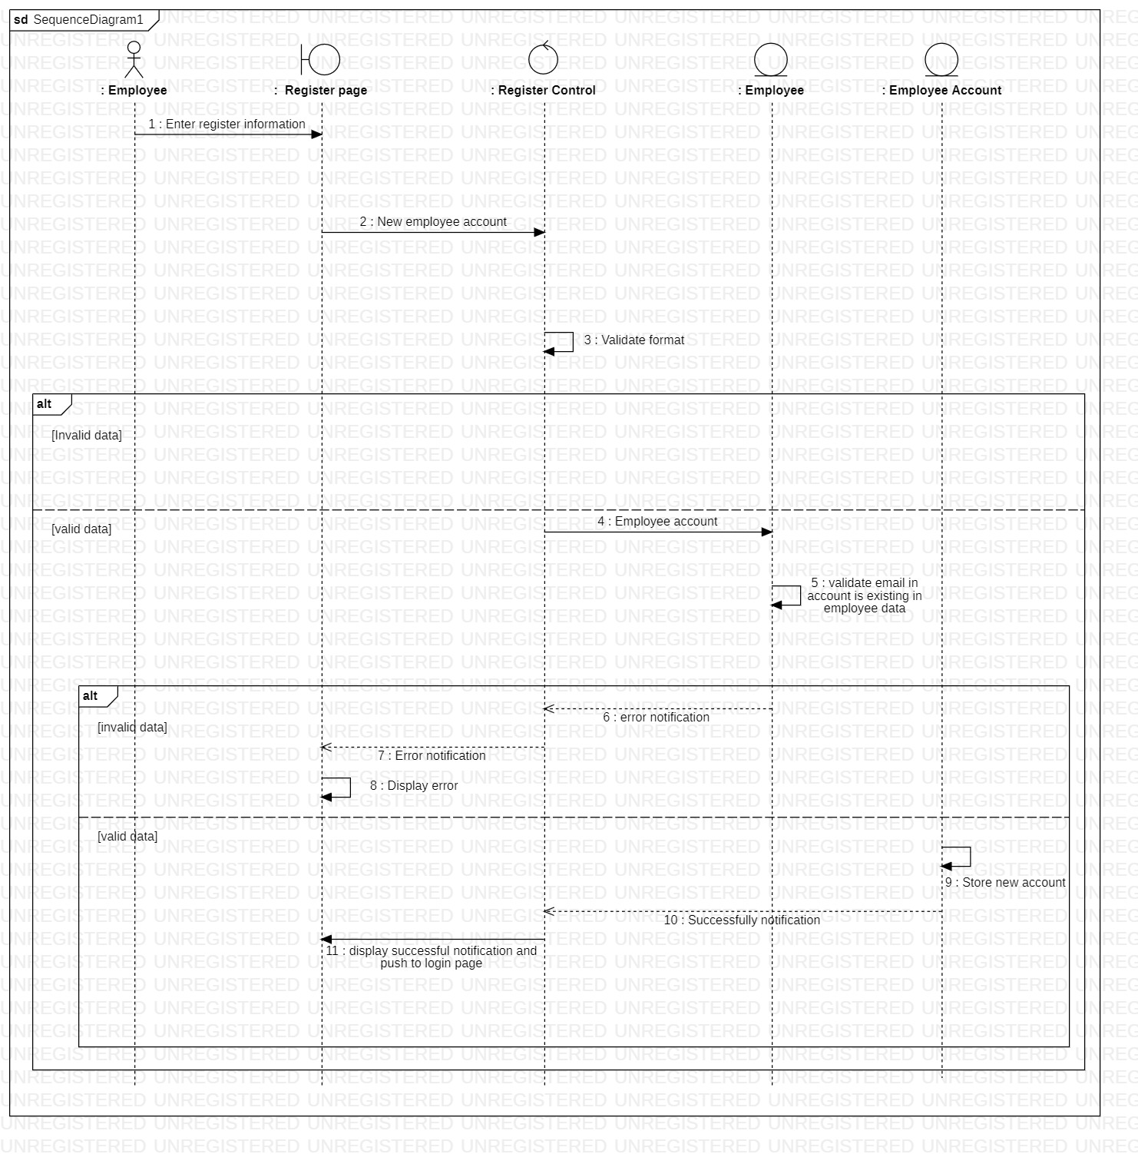

*3.3.1.2. Class diagram*

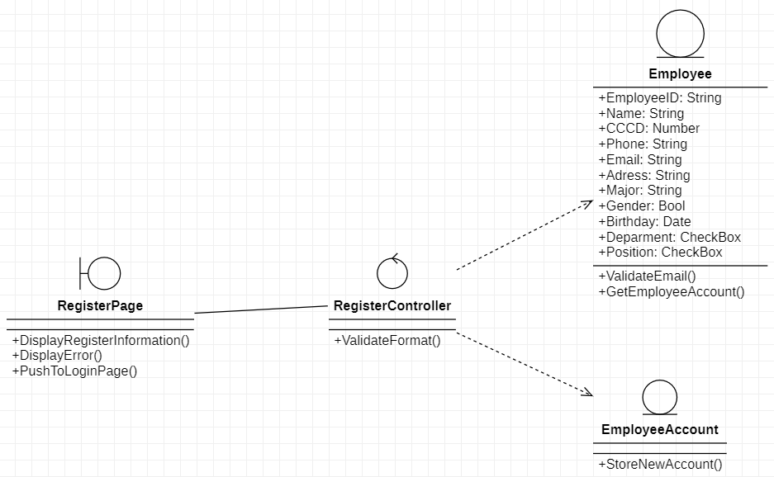

**3.3.2. Manage employee**

*3.3.2.1. Sequence diagram*

3.3.2.1.a. Insert

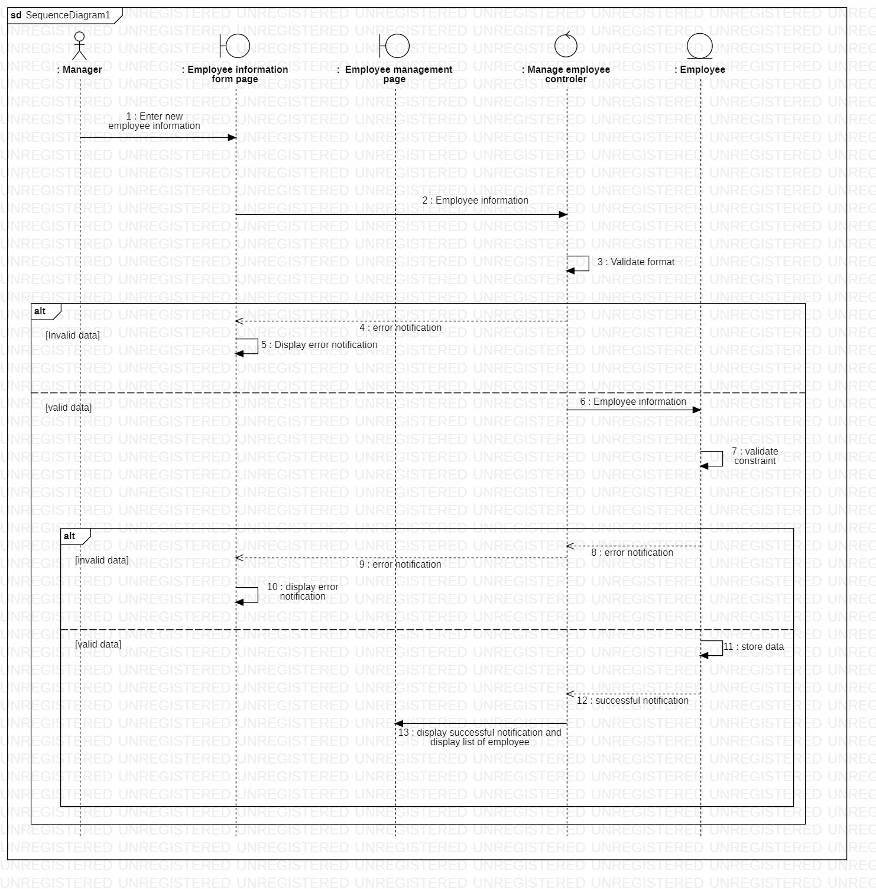

3.3.2.1.b. Update

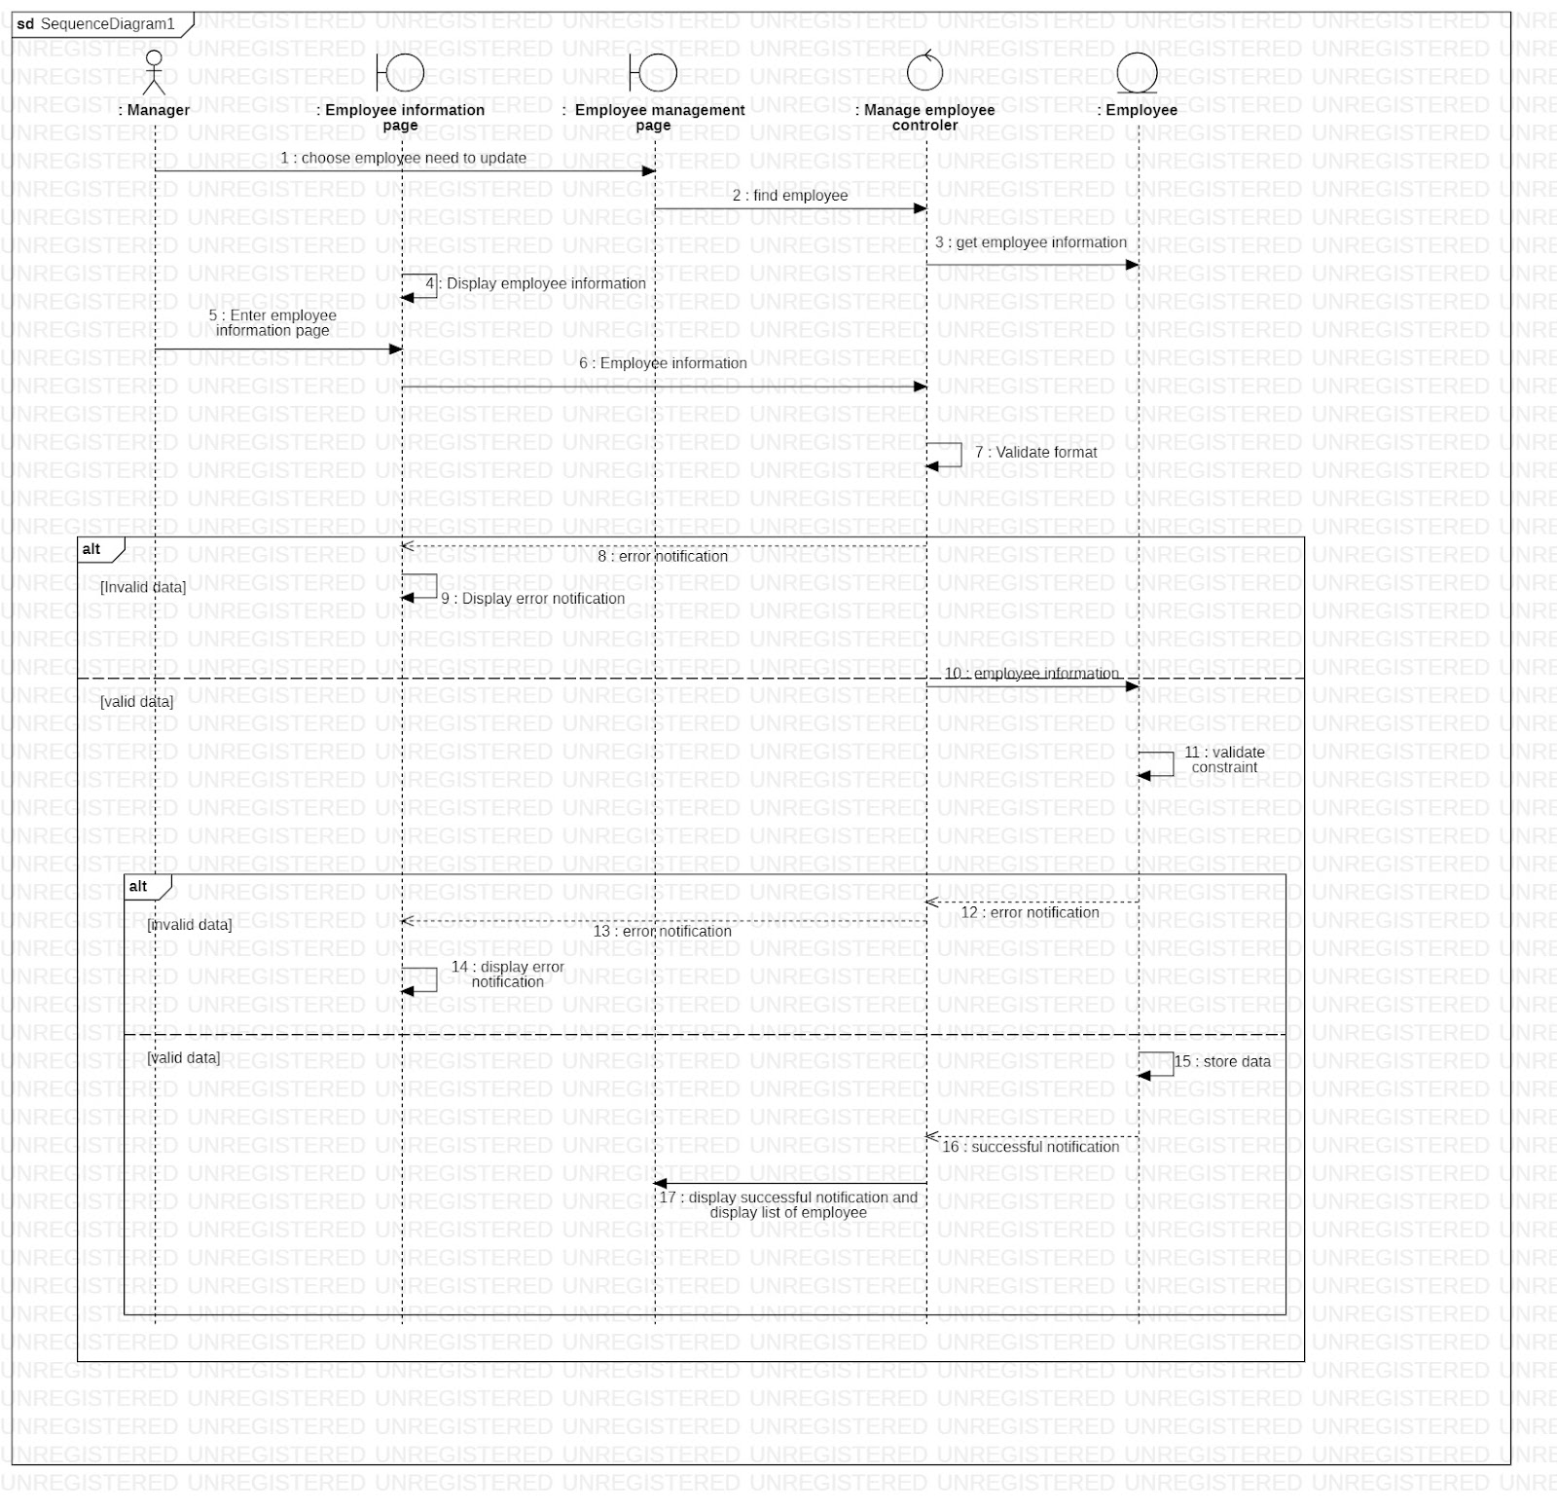

3.3.2.1.c. Delete

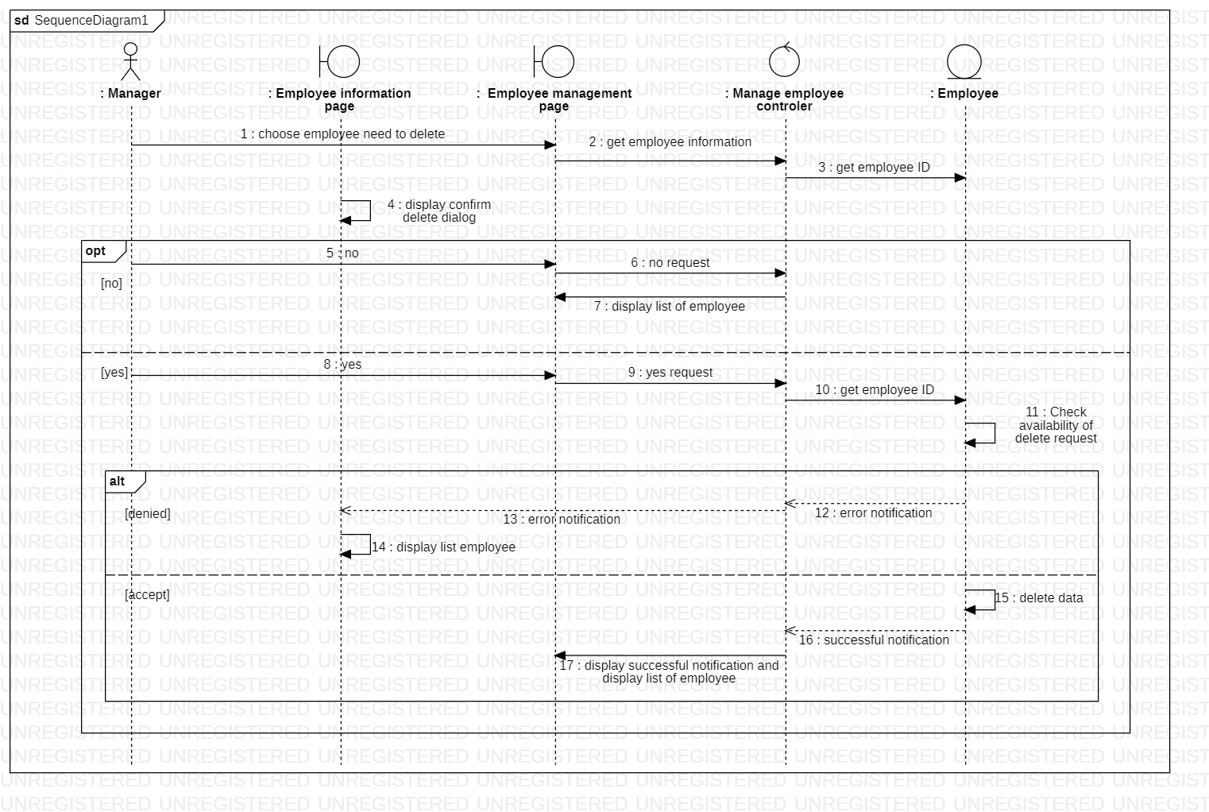

3.3.2.1.d. Search employee information

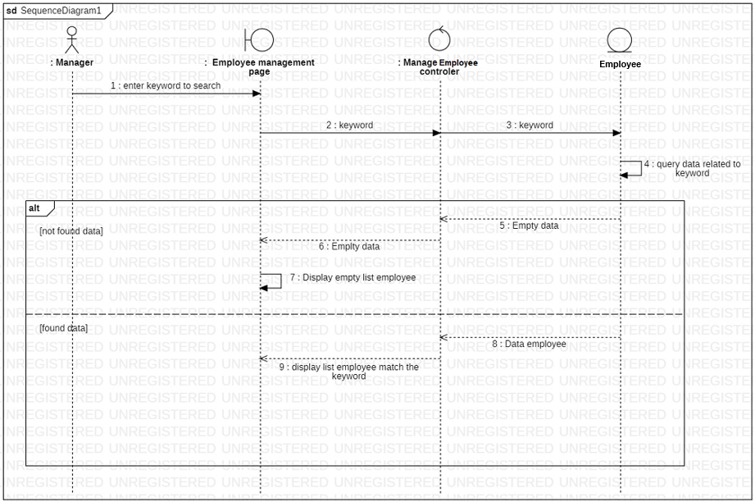

*3.3.2.2. Class diagram*

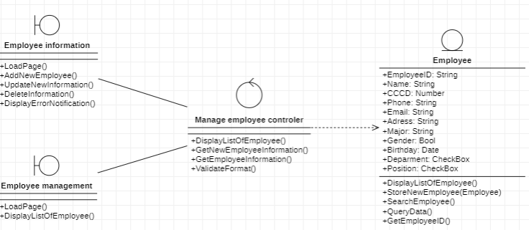

**3.3.3. Manage department**

*3.3.3.1. Sequence diagram*

3.3.3.1.a. Insert

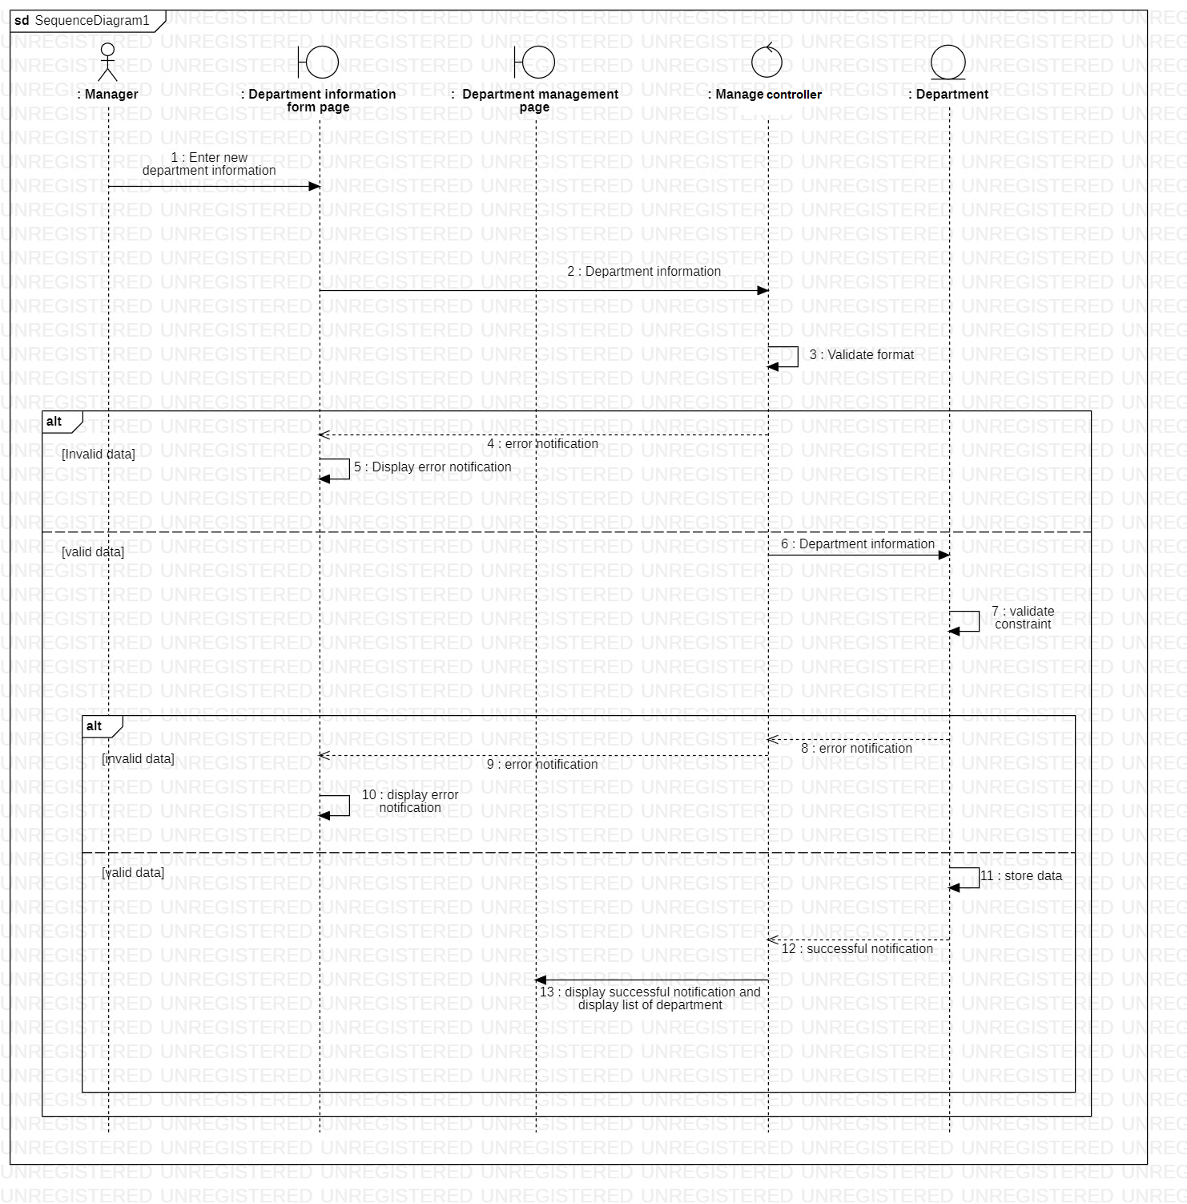

3.3.3.1.b. Delete

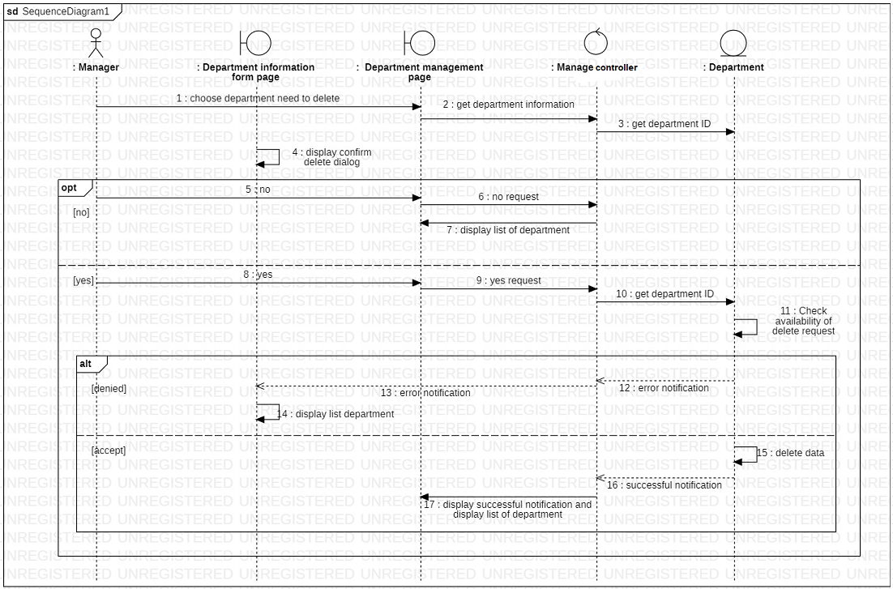

3.3.3.2. Class diagram

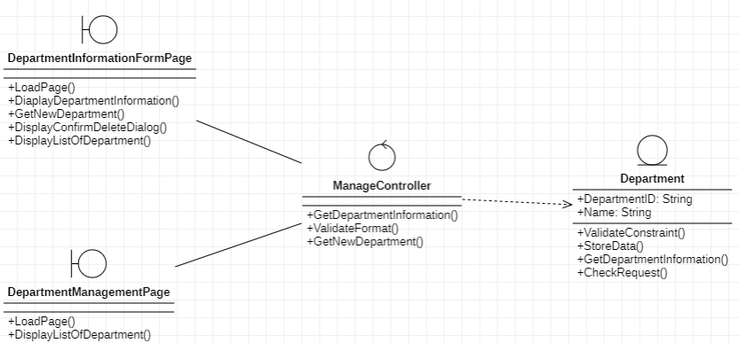

**3.3.4. Manage salary**

*3.3.4.1. Sequence diagram*

3.3.4.1.a Update salary of each employee

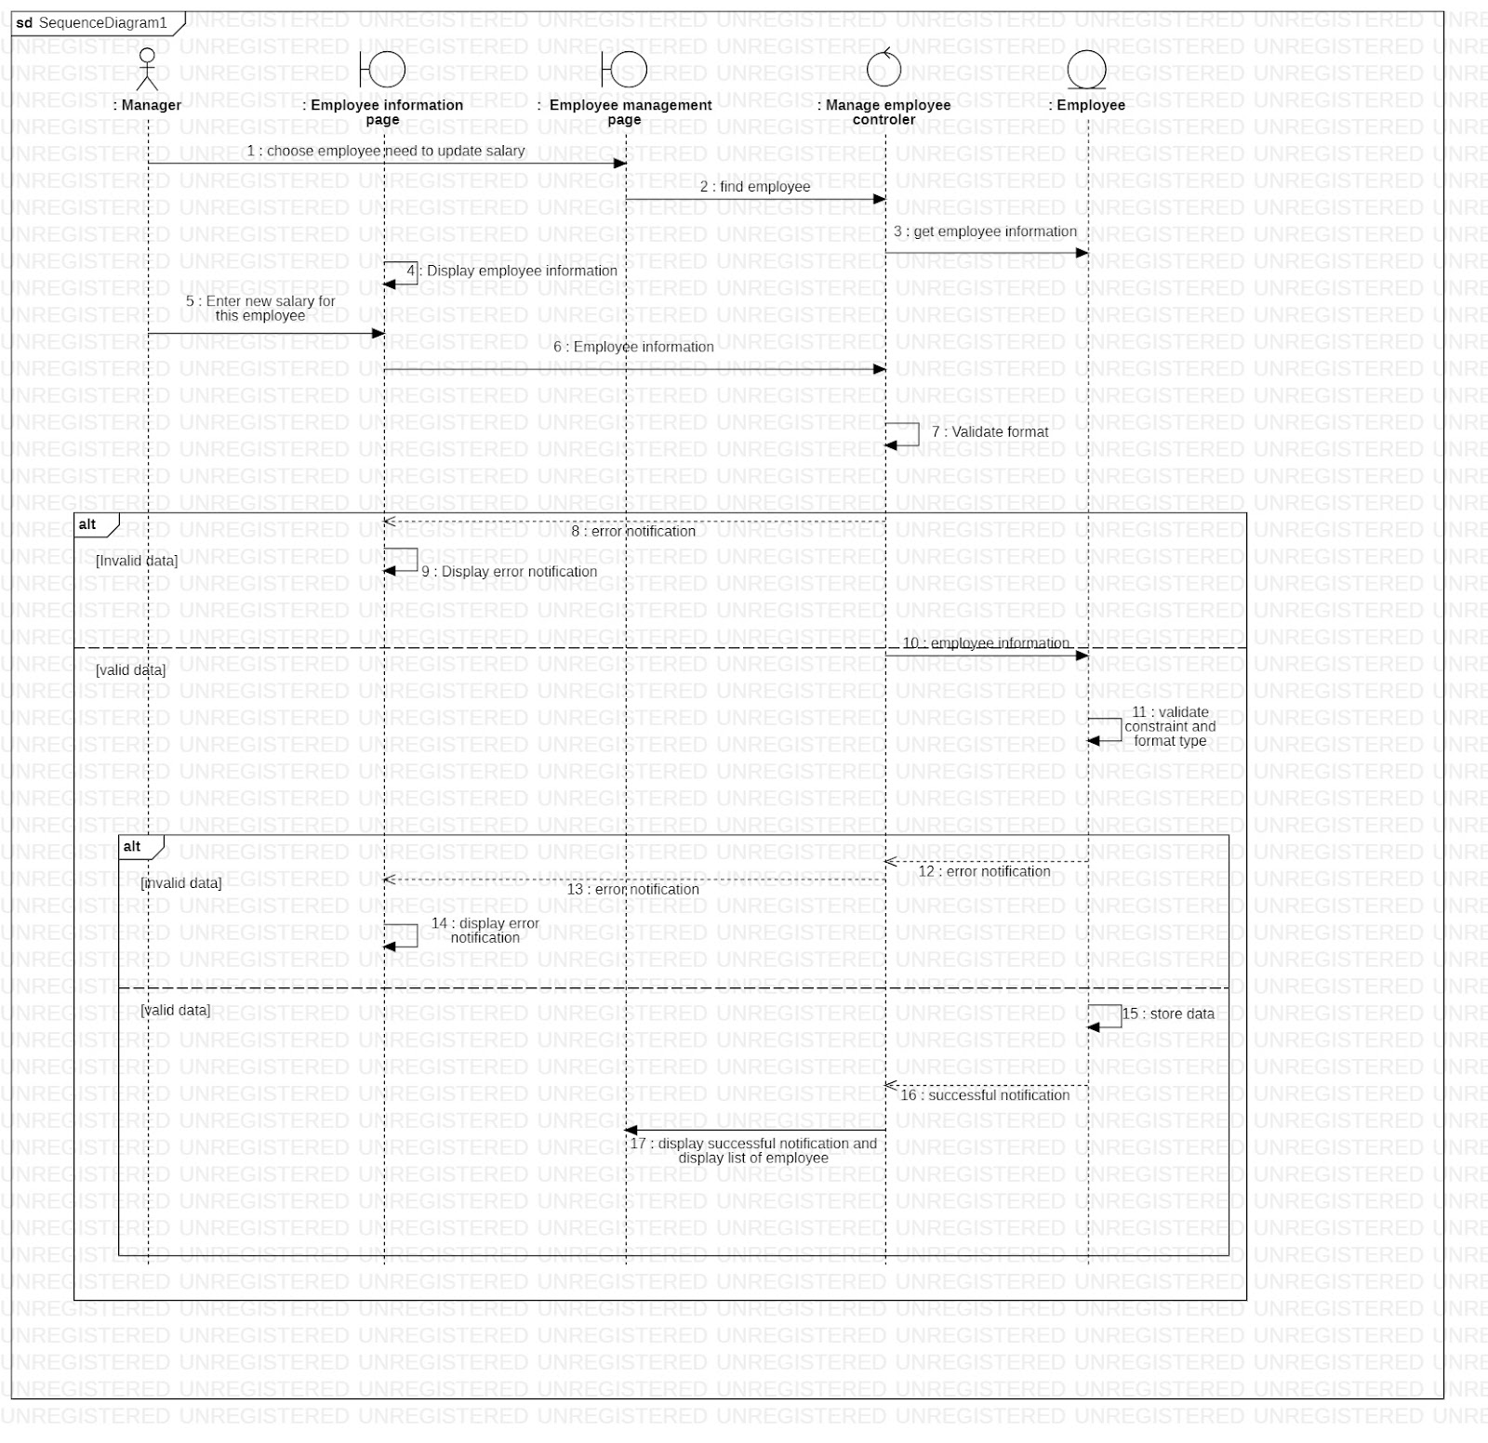

3.3.4.1.b Search salary

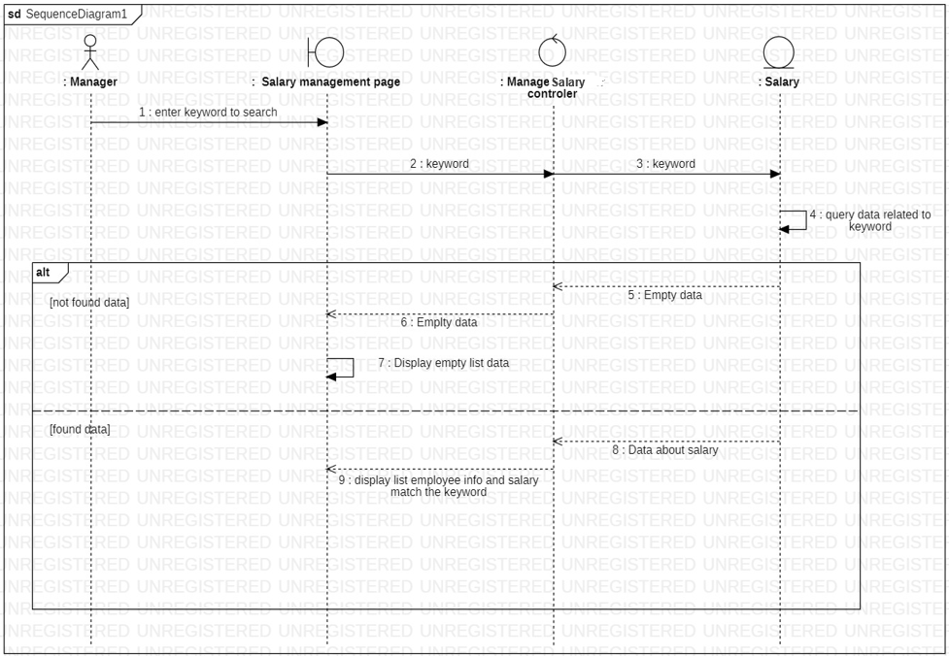

3.3.4.2. Class diagram

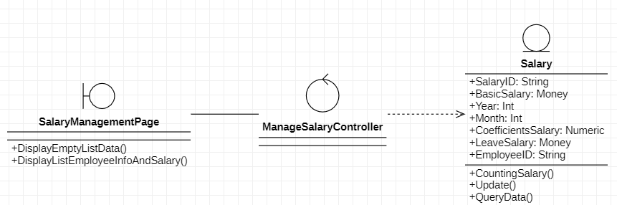

**3.3.5 Manage Day-off**

*3.3.5.1 Sequence diagram*

Delete Furlough

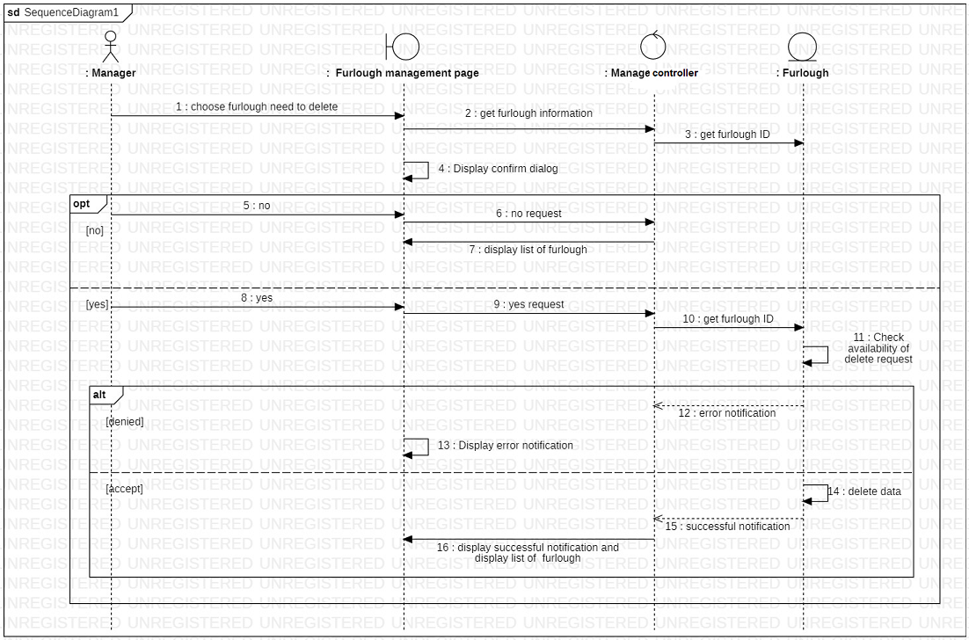

3.3.5.2 Class diagram

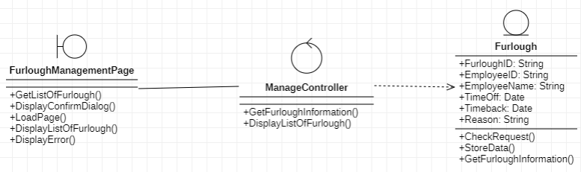

**3.4. Class Diagram and Entity class diagram**

**3.4.1. Employee overview class diagram**

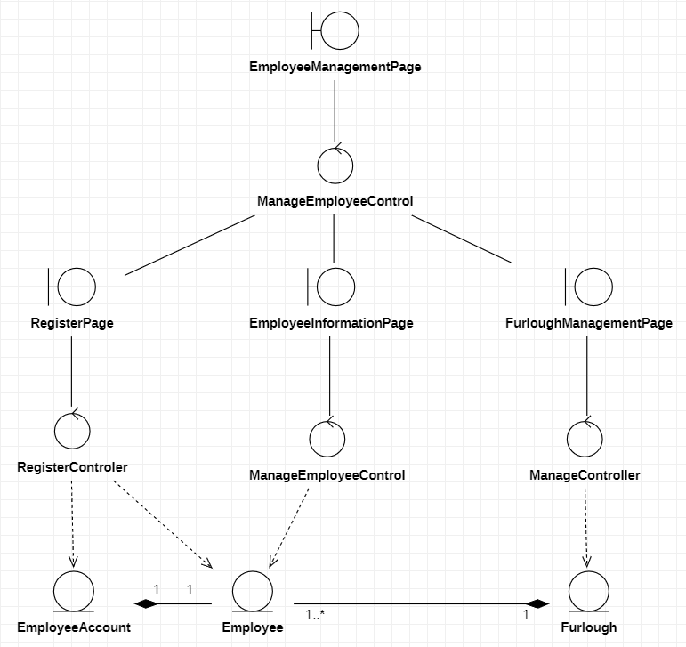

**3.4.2. Manager overview class diagram**

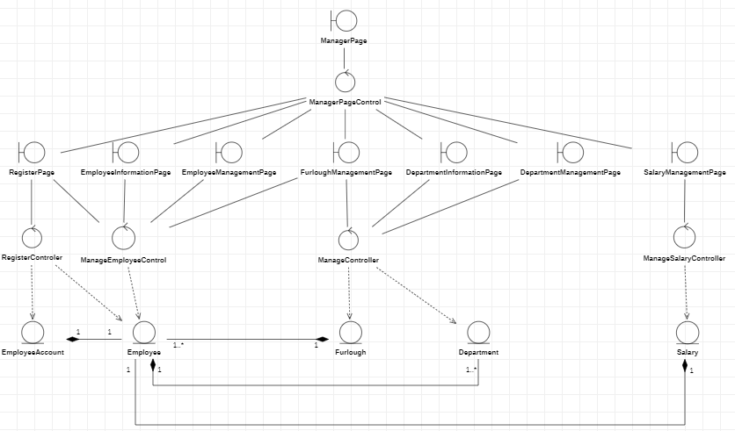

**3.4.3. Administrator overview class diagram**

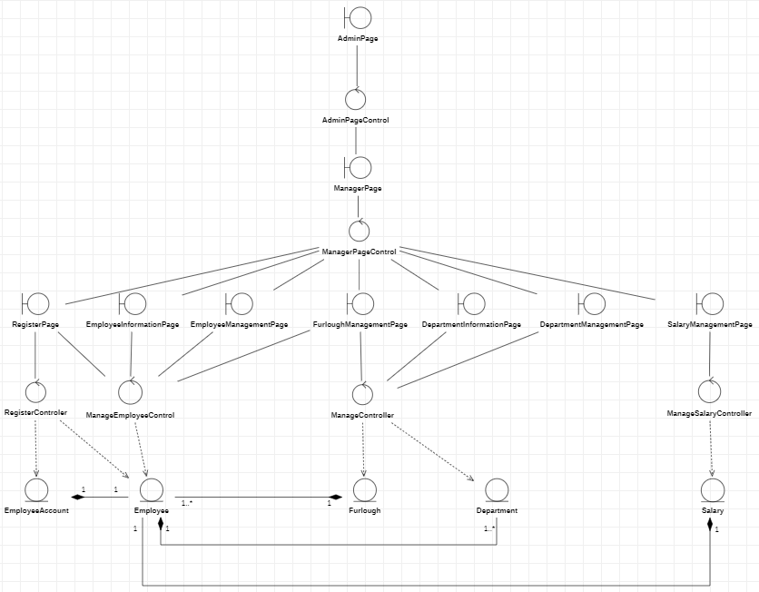

**3.4.4. Entity class diagram**

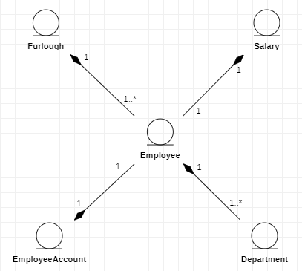

**3.4.5. Class diagram specification**

**3.4.5.1. Employee**

|  |  |  |
| --- | --- | --- |
| Employee | | |
| Attribute | Variable | Meaning |
| employeeID: String | Employee ID generated by system |
| name: String | Full name of employee |
| gender: String | Gender of employee |
| dateOfBirth: Datetime | Day of birth of employee |
| citizenCard: String | Citizen identity card of employee |
| phone: String | Phone number of employee |
| email: String | Email of employee |
| address: String | Address of employee |
| education: String | Education level of employee |
| avatar: String | Avatar of employee |
| departmentID: String | Department where employee in |
| positionID: String | Position of employee |
| Operation | Function | Meaning |
| validateInputData(employee): bool | Validate if the input data is  duplicate to the existed data |
| storeNewEmployee(employee): bool | Store new employee after validation |
| validateSigninData(username, password): bool | Validate if the sign in data is  correct with the database |
| storeSignInStatus(): Bool | Change the sign in status  attribute |
| getProfileData(): employee | Get employee profile |
| getListOfEmployee(): Array | Get list of employee to perform  on the Employee Management  page of manager |
| searchEmployee(String): Array | Search employees related to  keyword for displaying on the  Employee Management page of  manager |

3.4.5.2. Department

|  |  |  |
| --- | --- | --- |
| Department | | |
| Attribute | Variable | Meaning |
| departmentID: String | Department ID generated by system |
| name: String | Name of department |
| Operation | updateDepartment() | Update department’s information |
|  | ValidateContraint() | Verifi department information in the database |
|  | StoreData | Save updated information in the database |

3.4.5.3. Salary

|  |  |  |
| --- | --- | --- |
| Salary | | |
| Attribute | Variable | Meaning |
| salaryID: String | Salary ID generated by system |
| basicSalary: money | Basic salary of employee |
| year: int | Year of salary |
| month: int | Month of salary |
| coefficientsSalary: numeric | Coefficients salary of employee |
| leaveSalary: money | Leave salary of employee |
| employeeID: String | Employee ID has salary |
| Operation | countingSalary() | Calculate salary for employee |
| update() | Update salary’s employee information |

3.4.5.4. Employee account

|  |  |  |
| --- | --- | --- |
| EMPLOYEE ACCOUNT | | |
| Attribute | Variable | Meaning |
| userName: String | Account’s name of user |
| userPass: String | Account’s password of user |
| email: String | Email of user |
| phone: String | Phone number of user |
| permission: int | User’s role |
| avatar: image | Avatar of user |
| Operation | login() | User login action |
| update() | Update account’s information |
| searchEmployee() | Search employee |
| updateDepartment() | Update department |
| searchDepartment() | Search department |
|  |  |

3.4.5.5. Day off

|  |  |  |
| --- | --- | --- |
| Day off | | |
| Attribute | Variable | Meaning |
| dayOffID: String | Day off ID generated by system |
| fromDate: datetime | Start date of days off |
| toDate: datetime | End date of days off |
| reason: String | Reason for days off |
| employeeID: String | Employee of day off |
| Operation | update() | Update days off information |

**3.5 State diagram**

**3.5.1 State diagram for object “Register”**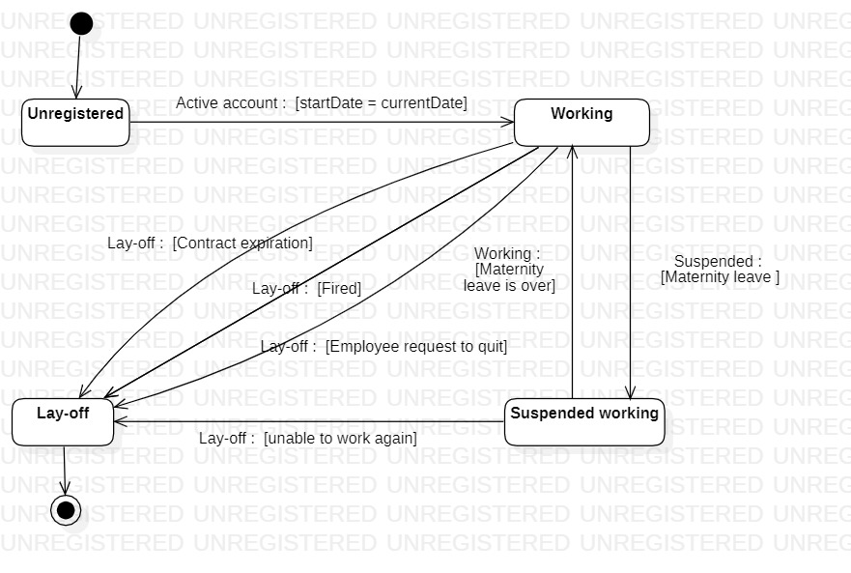

**3.6. Mapping to Relational Model from Entity class diagram**

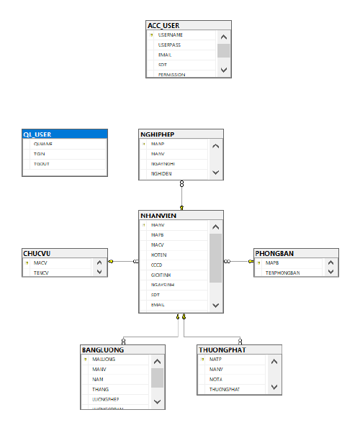

**CHAPTER 4: IMPLEMENTATION AND TESTING**

**4.1. Introduction to the implementation environment**

4.1.1. Development Environment

* Operating system: Window 10
* Database: MySQL Server database
* Text Editor: Visual Studio Code
* App GUI: Winform

4.1.2. Deployment Environment

* Operating system: Window 10 or upper
* To be installed: MySQL Server database

**4.2. User Interface**

4.2.1. Sign-up interface

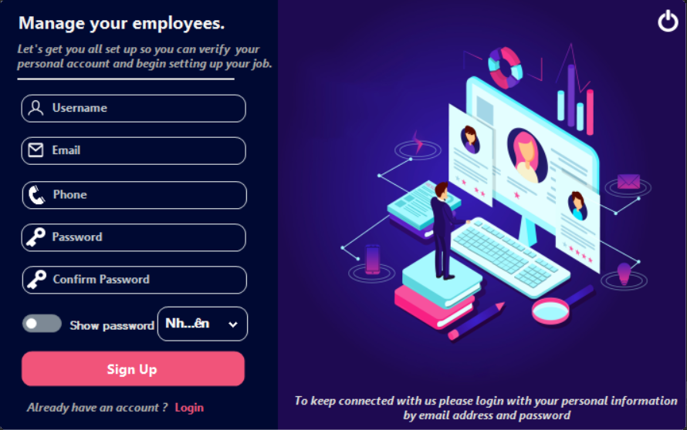

4.2.2. Sign-in interface

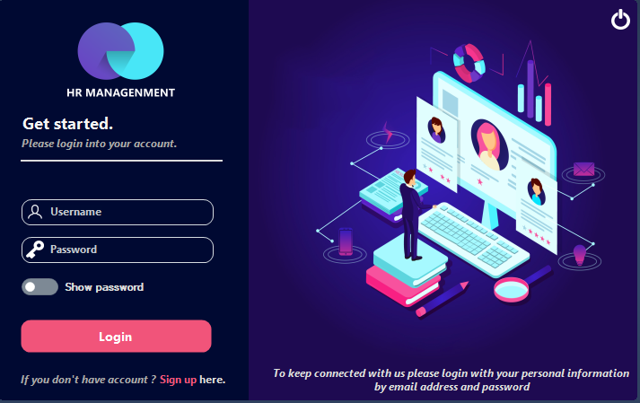

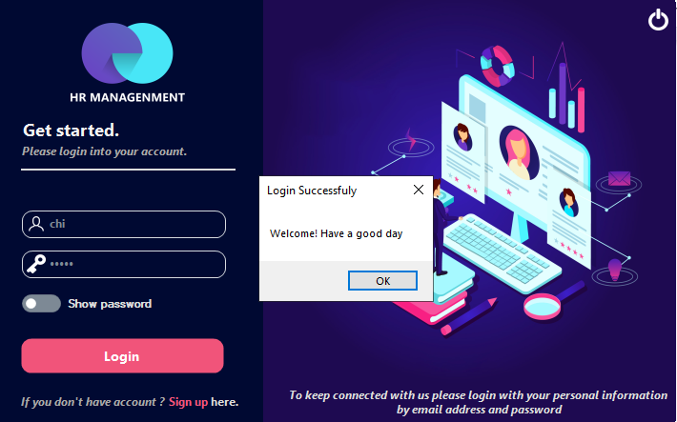

4.2.3. Home page interface

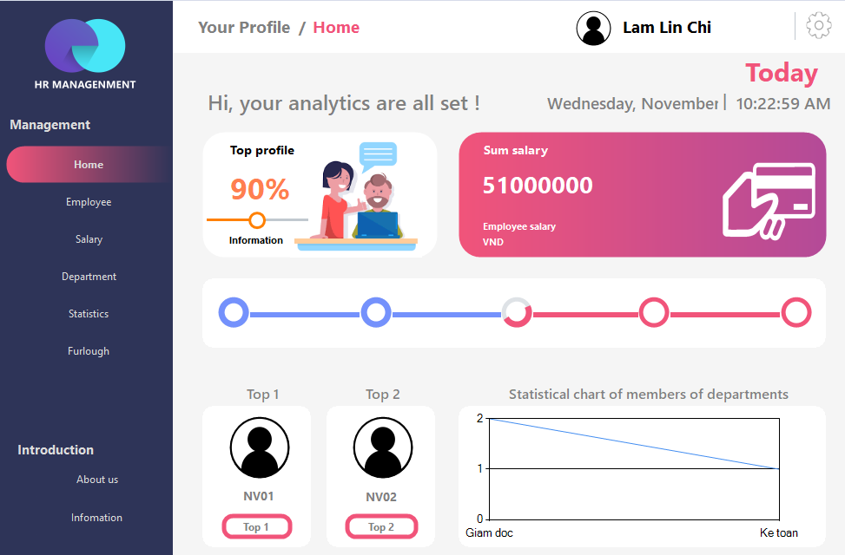

4.2.4. Employee’s home page interface

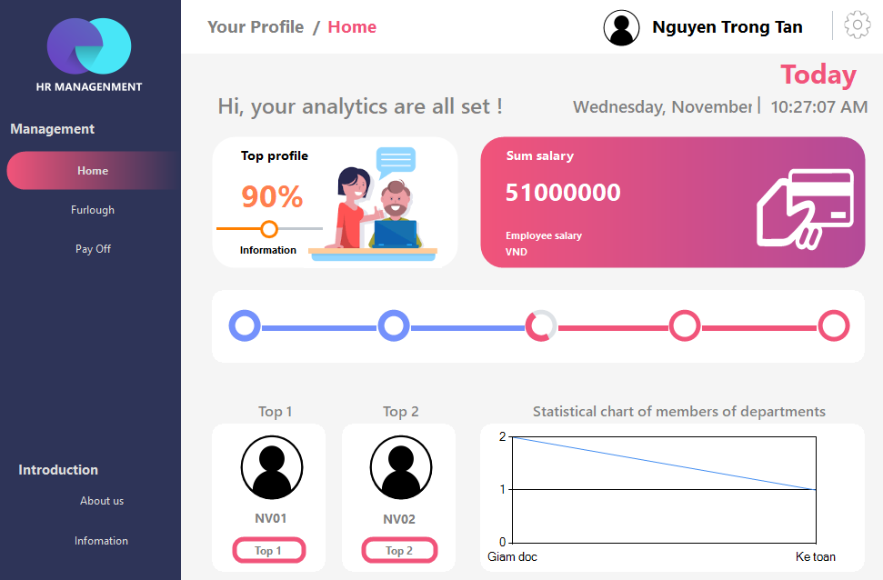

4.2.5. Personal information interface

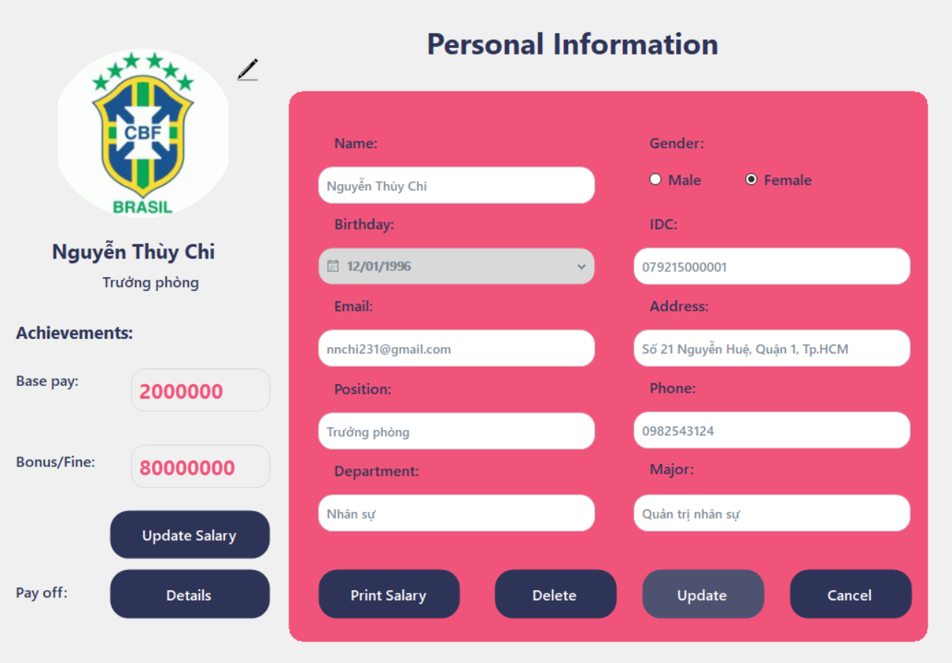

4.2.6. Manage employee interface

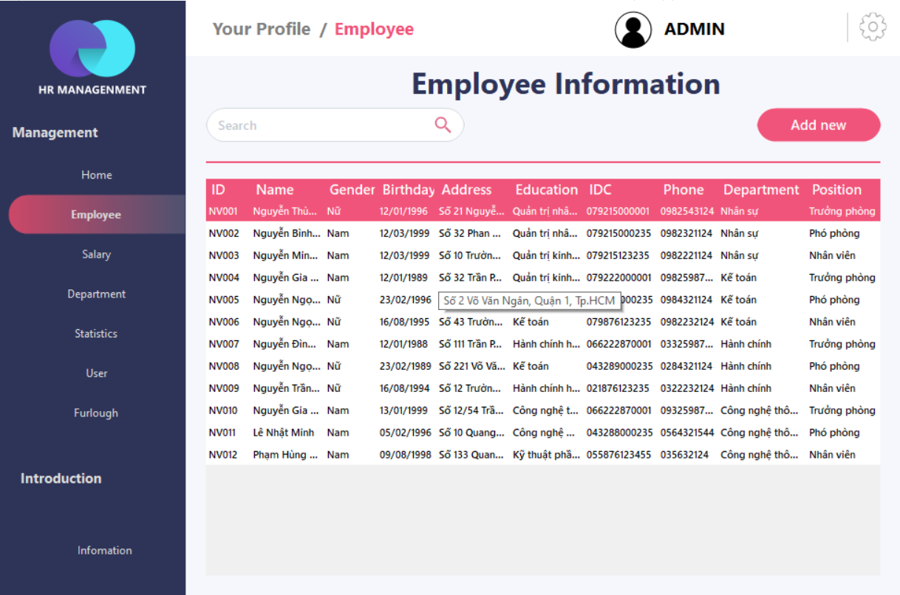

4.2.7. Manage salary interface

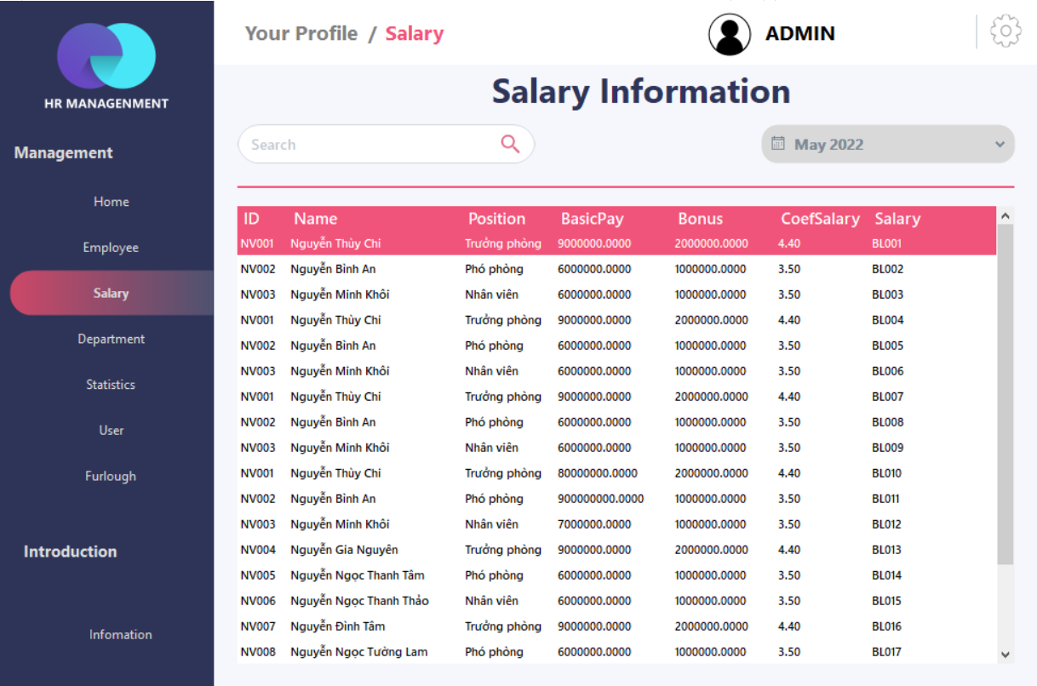

4.2.8. Manage department interface

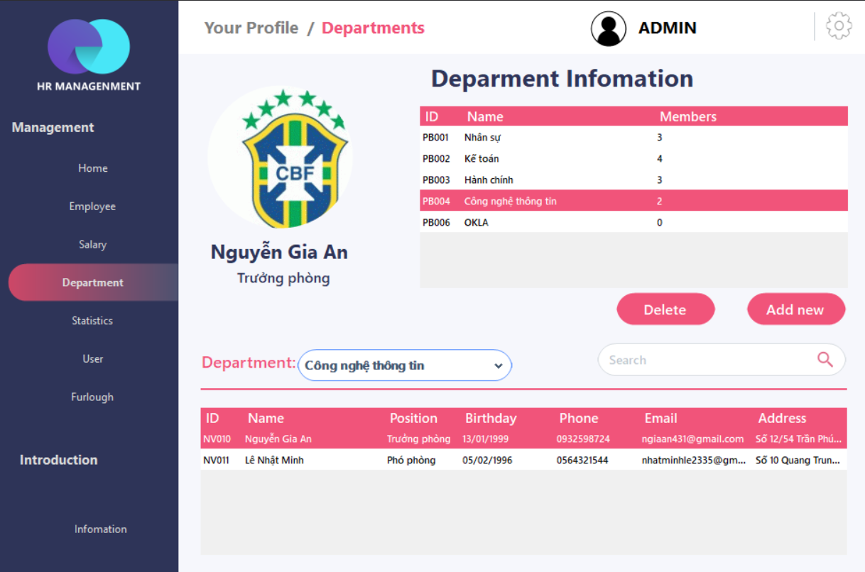

4.2.9. Statistic interface

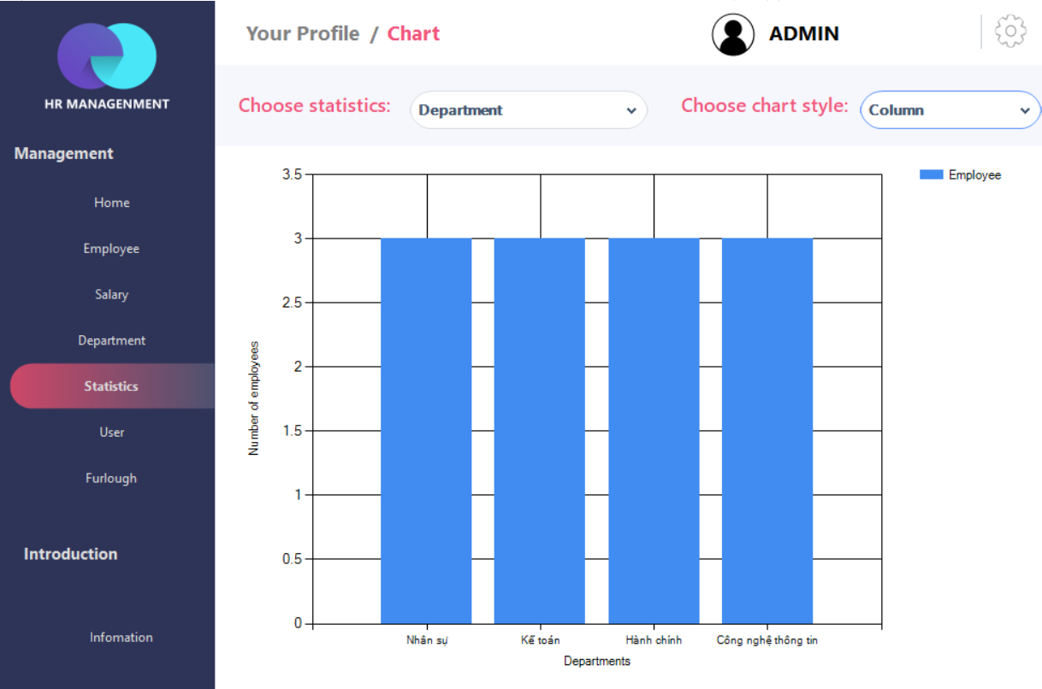

4.2.10. Manage user interface (admin)

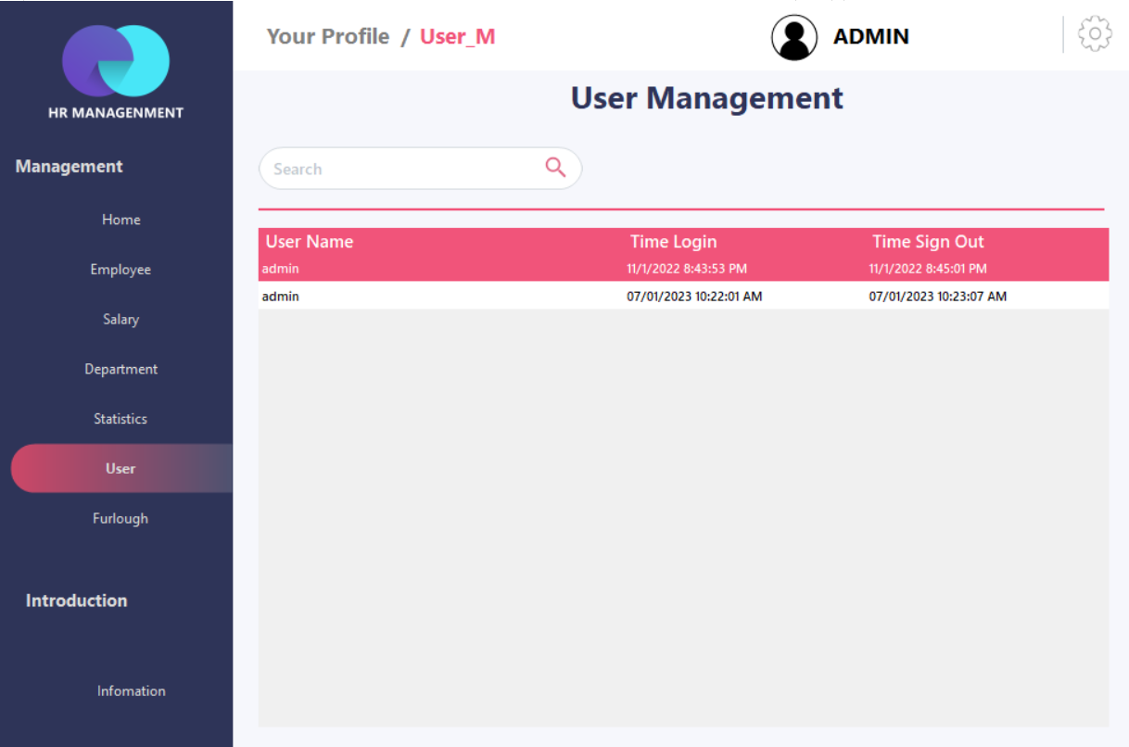

4.2.11. Manage furlough interface

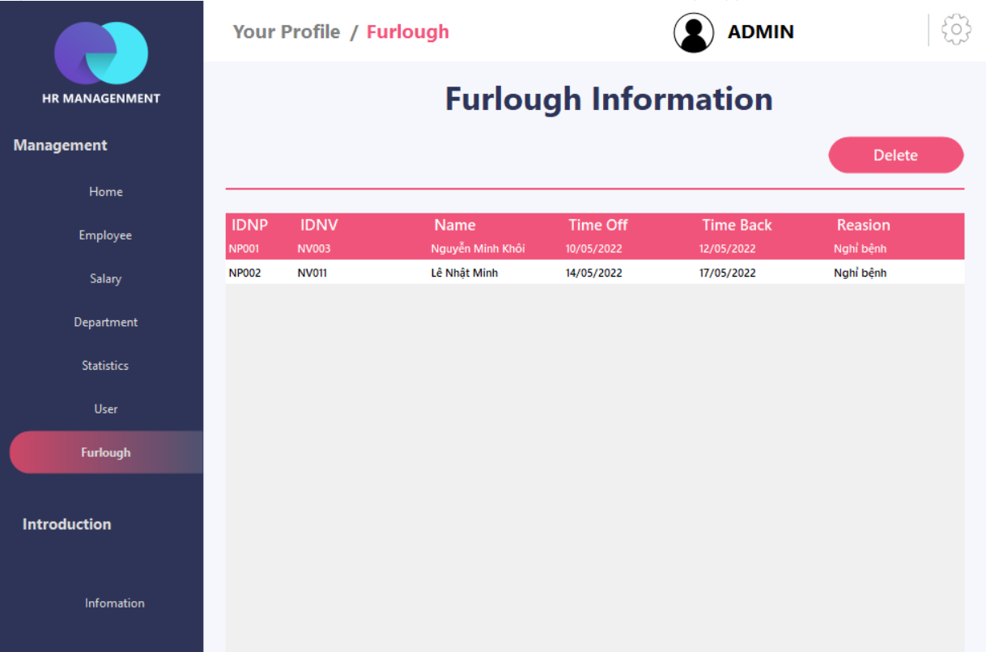

1. Detail information of employee who has a furlough

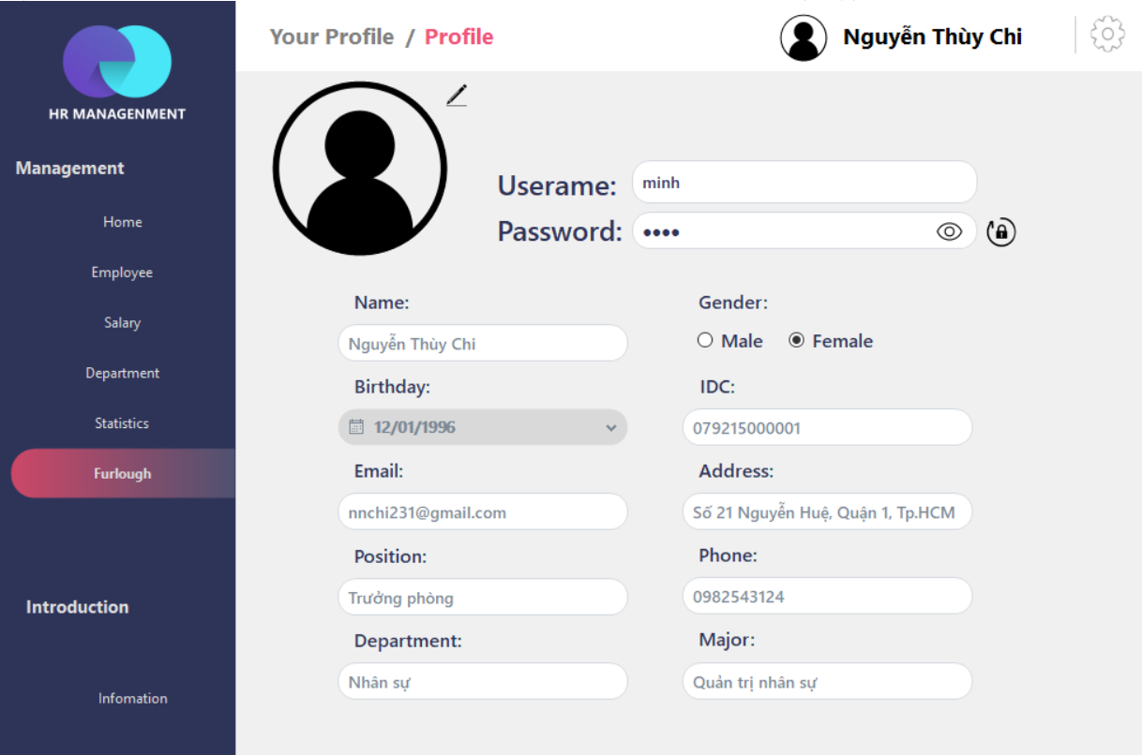

1. Furlough interface (employee)

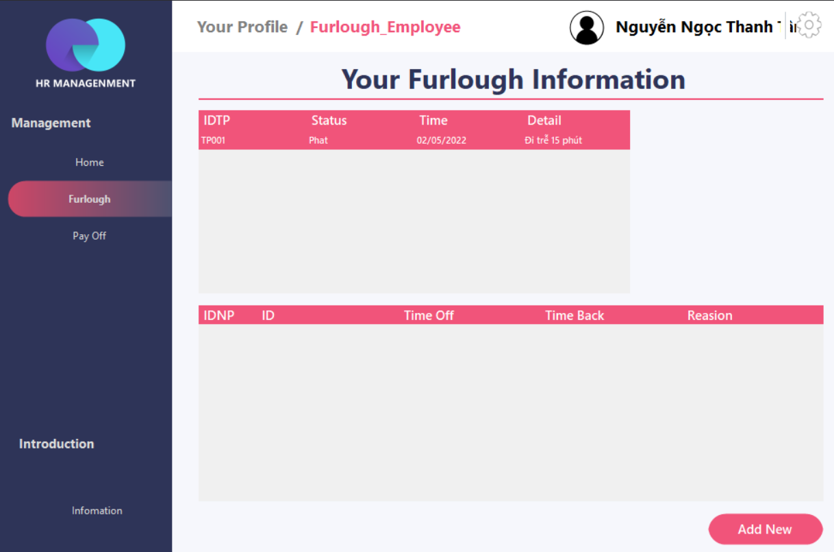

1. Add new furlough interface (manager)

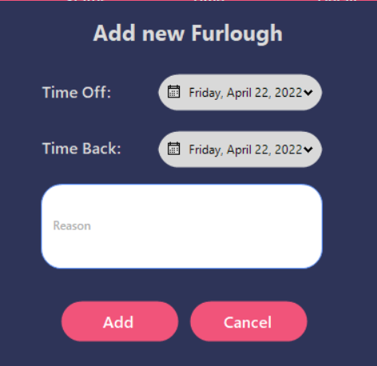

4.2.12. Pay off interface (employee)

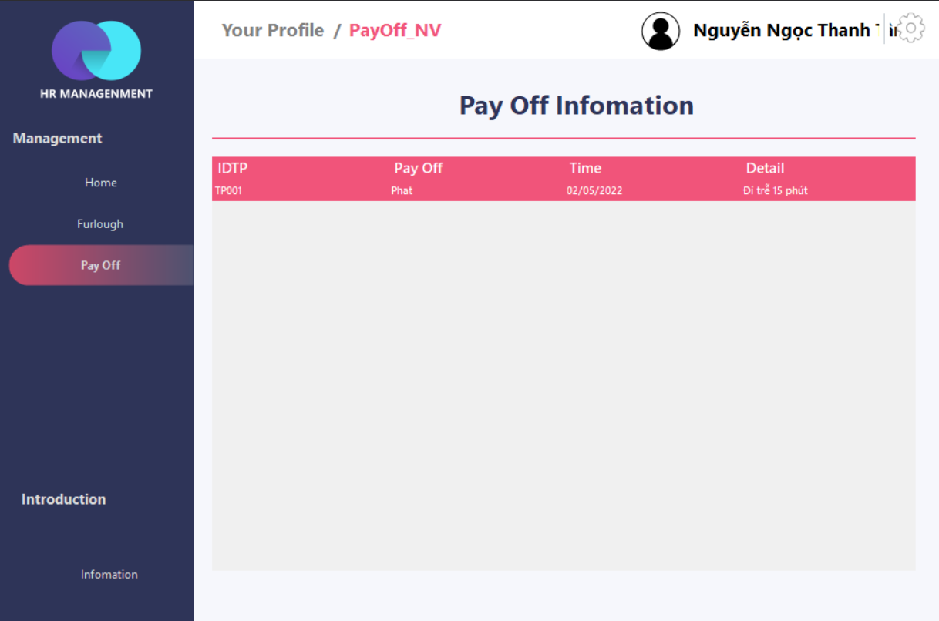

4.2.13. Pay off detail interface (manager, admin)

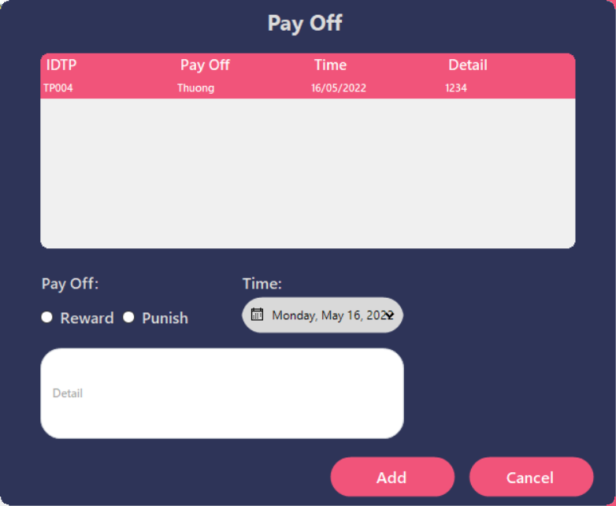

**CHAPTER 5: CONCLUSION**

**5.1. Project Achievement**

Human resource management is something that is a part that each company or business must do to guarantee that their operations operate smoothly. Because this is a good and beneficial topic, it can be commonly applied. As a result, our group decided to take this topic to develop a Human Resource Management System that simplifies and facilitates management while reducing manual volume of work to significantly boost human resources for company power.

Below this is our system primary functions:

* Manage employee
* Manage salary
* Manage department
* Manage furlough of employee
* Manage user
* Generate statistic about employee, salary

We used Winform for UI and MySQL Server technologies to build the systems. Thanks to the MVC design pattern, our project is separated into many modules easily, which helps us solve a lot of problems about project management.

**5.2. Limitation**

Due to the limited time of the study, the study has the following limitations:

* There is no data recovery and backup function yet.
* Incapable of managing retirees.
* Password for user not encrypted.
* Social benefits and personal income tax have not been computed.

**5.3. Development direction**

As mentioned in a previous section, our group believes that much more work needs to be done to perfect the Human Resource Management System. As a result, the group established the following objectives for future development of the topic:

* Build recovery and backup function.
* Build module for managing retirees.
* Encrypt password for security system.
* Counting salary with income tax and social benefits.

**CHAPTER 6: SELF ASSESSMENT**

|  |  |  |
| --- | --- | --- |
| **Name** | Phạm Phùng Gia Khiêm | |
| **Role** | Leader | |
| **Contribution** | **Report** | Chapter 3:   * Use-case diagram * Sequence Diagram and Class Diagram * Manage employee: search |
| **Demo project** | * Employee management (Back End) * Department management (Back End) * Counting salary (Back End) * Statistic (Front End + Back End) * Admin page (Front End + Back End) * Pay of (Back End + Front End) * Furlough (Back End) * Statistic |
| **Grade** | 10/10 | |

|  |  |  |
| --- | --- | --- |
| Name | Lê Thị Đoan Trang | |
| Role | Member | |
| Contribution | Report | Chapter 1:   * Scope of project * Developer tools & Technology   Chapter 2:   * Interview * Current organizational situation * Survey of the existing system * Software requirements: Functional   Chapter 3:   * Use-case specification and activity diagram (Activity Diagram) * Employee: Re-create password, Update personal information * Manager /Admin: Sign in, Sign-up, Re-create password , Search employee * Manage Salary (manager, admin): Search salary for each employee, Print pay slips * Manage Day off (manager, admin): Add Day off, Delete Day off * Administrator: Manage Manager’s account and Employee account * Sequence Diagram and Class Diagram   + Manage department: insert, delete * Class Diagram and Entity class diagram * Employee overview class diagram * Manager overview class diagram * Class diagram specification * Employee * Department * Salary   Chapter 4 |
| Demo project | * Employee management (Front End) * Home page (Front End) * Furlough (Front End) |
| Grade | 10/10 | |

|  |  |  |
| --- | --- | --- |
| Name | Phạm Khôi Nguyên | |
| Role | Member | |
| Contribution | Report | Chapter 2:   * Interview   Chapter 3:   * Use-case specification and activity diagram (Activity Diagram) * Manager: Insert Department * Administrator: Insert Department, Delete Department * Manage salary (manager, admin): Add pay off information * Sequence Diagram and Class Diagram * Manage employee: insert, update, delete * Delete Furlough * Class Diagram and Entity class diagram * Administrator overview class diagram   Chapter 5:   * Project achievement |
|  | Demo project | * Login page (Front End + Back End) * Department management (Front End) * User management (Front End + Back End) |
| Grade | 10/10 | |

|  |  |  |
| --- | --- | --- |
| Name | Trần Minh Ngọc | |
| Role | Member | |
| Contribution | Report | Chapter 1:   * Introduction * Problem of project * Objectives of project   Chapter 2:   * Interview * Current organizational situation * Survey of business processes, major activities * Software requirements: Non-functional   Chapter 3:   * Use-case specification and activity diagram (Activity Diagram) * Employee: Sign - in, Add day off * Manager: Insert employee, Update employee, Delete employee * Manager: Delete department * Manage Salary (manager, admin): Payroll * Administrator: Insert employee, Update employee, Delete employee * Sequence Diagram and Class Diagram * Sign - up * Update salary of each empoyee * Class Diagram and Entity class diagram * Entity class diagram * Class diagram specification * Position * Acc_user * Day off * Mapping to Relational Model from Entity clas diagram   Chapter 5:   * Limitation * Development direction |
| Demo project | * Counting salary (Front End) * Home Page (Front End) |
| Grade | 10/10 | |